**Product Marketing & Selling Portal**

## A PROJECT REPORT

*Submitted by*

## Misha Thakkar: 5079

**Name of Company**: Gateway Group Of Companies

**Date of Submission**: 23-July-2020

**Submitted To**

**K. S. School of Business Management**

M.Sc. – Computer Application and Information Technology



## CERTIFICATE

This is to certify that Project Work embodied in this project report titled “Product Marketing & Selling Portal" was carried out by “Hemang Gohel (16CP001)” (which was carried out at ***Gateway Group of Companies, Ahmedabad***) under the course CP446, Full Semester External Project for the partial fulfilment for the award of the degree of B. Tech. (Computer Engineering). Followings are the supervisors at the institute.

Date:

Place:

(Dr. Darshak G Thakore) Project Guide

Prof. & Head

Computer Engineering Department, BVM

(Prof. Bhavesh A Tanawala) Project Guide

Professor of Computer Engineering

## REPORT APPROVAL CERTIFICATE

The project work entitled **Product Marketing & Selling Portal** carried out by **Hemang Gohel (16CP001)** (which was carried out at ***Gateway Group of Companies, Ahmedabad***) is approved for the submission in the course CP446, Full Semester External Project for the partial fulfilment for the award of the degree of

B. Tech. (Computer Engineering).

(Name & Designation)

Date:

Place:

## DECLARATION OF ORIGINALITY

We hereby certify that we are the sole authors of this report under the course CP446 Full Semester External Project and that neither any part of this report nor the whole of the report has been submitted for a degree to any other University or Institution.

We certify that, to the best of our knowledge, the current report does not infringe upon anyone’s copyright nor violate any proprietary rights and that any ideas, techniques, quotations or any other material from the work of other people included in our report, published or otherwise, are fully acknowledged in accordance with the standard referencing practices. Furthermore, to the extent that we have included copyrighted material that surpasses the boundary of fair dealing within the meaning of the Indian Copyright (Amendment) Act 2012, we certify that we have obtained a written permission from the copyright owner(s) to include such material(s) in the current report and have included copies of such copyright clearances to our appendix.

We declare that this is a true copy of report, including any final revisions, as approved by report review committee.

We have checked write up of the present report using anti-plagiarism database and it is in allowable limit. Even though later on in case of any complaint pertaining of plagiarism, we are sole responsible for the same and we understand that as per UGC norms, University can even revoke the degree conferred to the student submitting this report.

Date:

Institute code: 007

Hemang Gohel (16CP001)

**CERTIFICATE**

This is to certify that Hemang Gohel of final year B. Tech (Computer Engineering) of Birla Vishvakarma Mahavidyalaya, Vallabh Vidyanagar has worked on his Full Semester External Project (CP446) entitled **“Product Marketing & Selling Portal”** under the supervision of Mr. Amrut Raval at Gateway Group of Companies, Ahmedabad. He has done his work sincerely and has completed his project. We found his work satisfactory.

Place: Ahmedabad Date:

Name and Signature of the External Supervisor

Seal of the company

## ACKNOWLEDGEMENT

I am highly thankful to find such an encouraging environment in my department developed by our faculties who keeps on motivating us to accomplish my goals. However, it would not have been possible without the kind support and help of many individuals. I would like to extend my sincere thanks to all of them.

First, I would like to express a deep sense of gratitude towards my external project guide **Mr. Amrut Raval**, Project Manager at Gateway Group of Companies, whose persistent effort of making the project better encouraged me to keep going. He even brainstormed with me for further innovative ideas. He encouraged me to develop a wider view towards research and life in general.

I would also like to thank my internal project guides **Prof** (**Dr**.**) D. G. Thakore** and **Prof. Bhavesh Tanawala** for giving me constant support for my project.

I am also thankful to **Prof (Dr.) D. G. Thakore**, HOD Computer Engineering, for his constant encouragement, co-operation and support.

Finally, I would like to thank Birla Vishvakarma Mahavidyalaya Engineering College for giving me this opportunity at Gateway Group of Companies, Ahmedabad which has helped me start my career.

Hemang Gohel

**ABSTRACT**

Product marketing & Selling Portal is a process of promoting and selling a product to a customer also it is defined as being the intermediary function between product development and product selling. This web application provides the facility to users for select the product according to their choice of category and location. User can only purchase the product if he/she is registered user and also user can promote own product into portal.it includes three modules: Admin, Login(Registered) User and Guest User.

### Admin

* Admin can manage user regarding roles, user accessibility and system configurations.
* Admin can manage application data regarding product, categories, locations and events details.
* Admin can manage requests regarding add new product, add new event and purchase products.
* Admin can manage product purchasement status and user verification.
* Admin has full access to check app logs and reports of user access.

### Login User

* Login User can add product to cart and purchase product according to their choice of category and location from portal.
* Login User can request to add new product and also can request to add new event.
* Login User can also check status of requested for purchase a product.

### Guest User

* Guest User can add product to cart and can interact with portal like login user except purchasing products. To purchase product guest user must be register self.
* Guest User can request to add new product and also can request to add new event.

# Table of Contents

Certificate ii

Report Approval Certificate iii

Declaration of Originality iv

Certificate from Industry v

Acknowledgement vi

Abstract vii

Table of Contents viii

List of Figures x

List of Tables xii

* 1. Introduction 1
  2. Project Details 1
  3. Purpose 1
  4. Project Scope 1
  5. Objective 2
  6. Technology and Literature Review 2
  7. Project Management 4
  8. Feasibility Study 4
     1. Technical Feasibility 4
     2. Time Schedule Feasibility 4
     3. Operational Feasibility 4
     4. Implementation Feasibility 5
  9. Project Planning 5
     1. Project Development Approach and Justification 5
     2. Milestones and Deliverables 6
     3. Roles and Responsibilities 6
     4. Group Dependencies 7
     5. Project Scheduling chart 7
  10. System Requirements Study 8
  11. Study of Current System 8
  12. Problems and Weaknesses of Current System 8
  13. User Characteristics 8
  14. Hardware and Software Requirements 8
  15. Assumptions and Dependencies 9
  16. System Analysis 10
  17. Requirements of New System 10
      1. Use-case Diagram 10
      2. System Requirements 12
  18. Features of New System 15
  19. System Activity 16
  20. System Design 19
  21. System Architecture Design 19
      1. Data Flow Diagram 19
      2. Class Diagram 20
      3. Sequence Diagrams 21
  22. Database Design 23
      1. Table and Relationship 23
      2. Data dictionary 24
  23. Implementation Planning 30
  24. Implementation Environment 30
  25. Modules Specification 30
  26. Coding Standards 31
  27. Testing 32
  28. Testing Plan 32
  29. Testing Strategy 32
  30. Testing Methods 33
  31. Test Cases 34

8.0 User Manual 37

9.0 Limitation and Future Enhancement 55

* 1. Conclusion and Discussion 56
  2. Conclusions and Future Enhancement 56
  3. Discussion 56
     1. Self Analysis of Project Viabilities 56
     2. Problem Encountered and Possible solutions 56
     3. Summary of Project work 57

REFERENCES 58

EXPERIENCE 59

**LIST OF FIGURES**

Figure 2.1 Agile Technology 5

Figure 2.2 Internal Coding Architecture 6

Figure 4.1 Use Case Diagram for Admin 10

Figure 4.2 Use Case Diagram for Registered User 11

Figure 4.3 Use Case Diagram for Visitor 12

Figure 4.4 Activity of Admin 16

Figure 4.5 Activity of Registered User 17

Figure 4.6 Activity of Visitor 18

Figure 5.1 Data Flow Diagram 19

Figure 5.2 Class Diagram 20

Figure 5.3 Sequence diagram for Admin 21

Figure 5.4 Sequence diagram for Registered User 22

Figure 5.5 Sequence diagram for Visitor User 22

Figure 5.6 Table Relation Schema 23

Figure 5.7 Product Data Dictionary 24

Figure 5.8 Category Data Dictionary 24

Figure 5.9 Location Data Dictionary 24

Figure 5.10 Event Data Dictionary 25

Figure 5.11 Product-Category Map Data Dictionary 25

Figure 5.12 Product-Location Map Data Dictionary 25

Figure 5.13 Product-Quantity Data Dictionary 25

Figure 5.14 Order Details Data Dictionary 26

Figure 5.15 Product-Cart Data Dictionary 26

Figure 5.16 Product-Checkout Data Dictionary 27

Figure 5.17 User Data Dictionary 27

Figure 5.18 User-Roles Data Dictionary 28

Figure 5.19 Location-City Data Dictionary 28

Figure 5.20 Location-State Data Dictionary 28

Figure 5.21 Location-Country Data Dictionary 28

Figure 5.22 Event-Inquiry Data Dictionary 28

Figure 5.23 Error Log Data Dictionary 29

Figure 8.1 Login Page 36

Figure 8.2 Registration Page 36

Figure 8.3 Admin Dashboard Page 37

Figure 8.4 Product Portal Page 38

Figure 8.5 Product Details Page 39

Figure 8.6 Product Cart Page 40

Figure 8.7 Product Checkout for Guest User Page 41

Figure 8.8 Product Checkout for Registered User Page 42

Figure 8.9 Product Purchasement Status Page 43

Figure 8.10 Request to Add New Product Page 44

Figure 8.11 Request to Add New Event Page 45

Figure 8.12 Product-List with Edit, Details and Delete Page 46

Figure 8.13 Category-List with Edit, Details and Delete Page 47

Figure 8.14 Location-List with Edit, Details and Delete Page 47

Figure 8.15 Event-List with Edit, Details and Delete Page 48

Figure 8.16 Event-Inquiry-List with Edit, Details and Delete Page 48

Figure 8.17 Add product Page 49

Figure 8.18 Product Details Page 49

Figure 8.19 Edit Product Page 50

Figure 8.20 Delete Product Page 50

Figure 8.21 Product Purchasement Request Page 51

Figure 8.22 Add Product Request Page for Admin 52

Figure 8.23 Add Event Request Page for Admin 52

# LIST OF TABLES

Table 2.1 Milestones and Deliverables 6

Table 2.2 Project Scheduling Chart 7

Table 7.1 Login & Register Module 33

Table 7.2 Admin Dashboard Module 34

Table 7.3 Registered User Portal Module 34

Table 7.4 Guest User Portal Module 35

# INTRODUCTION

## PROJECT DETAILS

Product marketing & selling portal is web based application. Product marketing is a process of promoting and selling a product to a customer also it is defined as being the intermediary function between product development and product selling. This web application provides the facility to users for select the product according to their choice of category and location. User can only buy the product if he/she is registered user and also User can promote own product into portal.

## PURPOSE

The main purpose of this project is to build the web application that enable the time management, secure transaction without data loses and making easy system that people can easily find their product information which they want. From the any place they can find the product according to their requirement they can search the category and location and get the data related their requirement. Manage Product marketing selling process. The time of User will be saved and user details are secured.

* + - It helps to user to get products according to their requirement.
    - It is not complex system.it is user friendly system.
    - User can purchase the product if they are registered user.
    - All Users can request to add own product for selling purpose and that request is monitored by Admin
    - All Users can do request for add event and that request is monitored by Admin.
    - Admin can manage the product purchase request, add product request and add event request.
    - Admin can add, update and delete products, categories, locations and events.

## PROJECT SCOPE

* + - Create and manage different users with varied roles and scopes for admin.
    - Create and manage products details for admin.
    - Create and manage locations details for admin.
    - Create and manage categories details for admin.
    - Create and manage events details for admin.
    - Create and manage user’s cart products for admin.
    - Manage add new product requests for admin.
    - Manage add new event requests for admin.
    - Manage product purchase requests for admin.
    - Manage product purchase status for admin.
    - Promote (Request to Add) Own Product for login user and guest.
    - Request to add new Event for login users and guest.
    - Create and manage all server configuration for admin.
    - Manage error logs and user interaction logs for admin.

## OBJECTIVE

Product Marketing and Selling Portal is E-Commerce Portal written in C# language,

.NET MVC framework based which supports promoting and selling a product to a customer also it is defined as being the intermediary function between product development and product selling. It provides facility to users for select the product according to their choice of category and location. Main objective of our portal is to enable time management, secure transaction without data loses and making easy system that people can easily find their product information which they want.

## TECHNOLOGY AND LITERATURE REVIEW

### VISUAL STUDIO

Microsoft Visual Studio is an integrated development environment (IDE) from Microsoft. It is used to develop computer programs, as well as websites, web apps, web services and mobile apps. Visual Studio uses Microsoft software development platforms such as Windows API, Windows Forms, Windows Presentation Foundation, Windows Store and Microsoft Silverlight. It can produce both native code and managed code [1].

Visual Studio includes a code editor supporting IntelliSense (the code completion component) as well as code refactoring. The integrated debugger works both as a source-level debugger and a machine-level debugger. Other built-in tools include a code profiler, designer for building GUI applications, web designer, class designer, and database schema designer. It accepts plug-ins that enhance the functionality at almost every level—including adding support for source control systems (like Subversion and Git) and adding new toolsets like editors and visual designers for domain-specific languages or toolsets for other aspects of the software development lifecycle (like the Azure DevOps client: Team Explorer) [1].

### SQL SERVER

Microsoft SQL Server is a relational database management system developed by Microsoft. As a database server, it is a software product with the primary function of storing and retrieving data as requested by other software applications—which may run either on the same computer or on another computer across a network (including the Internet) [1].

### C#

C# is a general-purpose, multi-paradigm programming language encompassing strong typing, lexically scoped, imperative, declarative, functional, generic, object-oriented (class-based), and component-oriented programming disciplines. It was developed around 2000 by Microsoft as part of its .NET initiative, and later approved as an international standard by Ecma (ECMA-334) and ISO (ISO/IEC 23270:2018). Mono is the name of the free and open-source project to develop a compiler and runtime for the language. C# is one of the programming languages designed for the Common Language Infrastructure (CLI) [1].

### .NET Framework

.NET Framework is a software framework developed by Microsoft that runs primarily on Microsoft Windows. It includes a large class library called Framework Class Library(FCL) and provides language interoperability (each language can use code written in other languages) across several programming languages. Programs written for .NET Framework execute in a software environment (in contrast to a hardware environment) named the Common Language Runtime(CLR). The CLR is an application virtual machine that provides services such as security, memory management, and exception handling. As such, computer code written using .NET Framework is called "managed code". FCL and CLR together constitute the .NET Framework [1].

.NET Framework led to a family of .NET platforms targeting mobile computing, embedded devices, alternative operating systems, and web browser plug-ins. A reduced version of the framework, .NET Compact Framework, is available on Windows CE platforms, including Windows Mobile devices such as smartphones. .NET Micro Framework is targeted at very resource-constrained embedded devices. Silverlight was available as a web browser plugin. Mono is available for many operating systems and is customized into popular smartphone operating systems (Android and iOS) and game engines. .NET Core targets the Universal Windows Platform (UWP), and cross- platform and cloud computing workloads[1].

# PROJECT MANAGEMENT

## FEASIBILITY STUDY

### TECHNICAL FEASIBILITY

The technical issue usually raised during the feasibility stage of the investigation includes the following:

* + - * Does the necessary technology exist to do what is suggested?
      * Do the proposed equipment have the technical capacity to hold the data required to use the new system?
      * Will the proposed system provide adequate response to inquiries, regardless of the number or location of Buyer?
      * Can the system be upgraded if developed?
      * Are there technical guarantees of accuracy, reliability, ease of access and data security?

### TIME SCHEDULE FEASIBILITY

The complete concept of the project may not be achieved in the given time period of 4 months. Although, basic requirements and overviewed implementations can be fulfilled and presented perfectly [2].

### OPERATIONAL FEASIBILITY

Proposed projects are beneficial only if they can be turned out into information system. That will meet the organization’s operating requirements. Operational feasibility aspects of the project are to be taken as an important part of the project implementation. Some of the important issues raised are to test the operational feasibility of a project includes the following: -

* + - * Will the system be used and work properly if it is being developed and implemented?
      * Will there be any resistance from the user that will undermine the possible application benefits?

This system is targeted to be in accordance with the above-mentioned issues. Beforehand, the management issues and user requirements have been taken into consideration. So, there is no question of resistance from the users that can undermine the possible application benefits [2].

**Performance: -** The current operation mode provides the adequate throughput, though it is dependent on quality of hardware and environmental conditions.

**Information: -** The information requirement for the user is provided and hence end user can use the system feasibly.

**Economy: -** The system does not require any extra operational cost.

**Efficiency: -** The system utilizes the minimum resources without compromising the efficiency and working of the application under any operational conditions.

### ECONOMIC FEASIBILITY

This feasibility study measures the cost effectiveness of the project, taking benefits and limitations into considerations. As the system uses some of open source resources and well know & worldwide highly use web platforms, it is economically feasible to develop and use the application [2].

### IMPLEMENTATION FEASIBILITY

Implementation feasibility is concerned with specifying external resources and software that will successfully satisfy the requirements. More importance is given to external resources and configuration of the system rather than the actual map of the hardware. Financial consideration is also considered at this stage. It even requires better and efficient formation of coding for developing the required components [2].

## PROJECT PLANNING

### PROJECT DEVELOPMENT APPROACH AND JUSTIFICATION

We have used Agile Methodology. Agile Methodology is one of the most popular methodologies currently being used for software development. It can enable companies to deliver a flexible, scalable and adaptive software development experience. It helps quickly create working software, in frequent iterations, building the highest priority features first [3].

This is precisely why Agile methodologies to build and maintain high- quality software products. It has helped us to successfully release numerous products into the market.

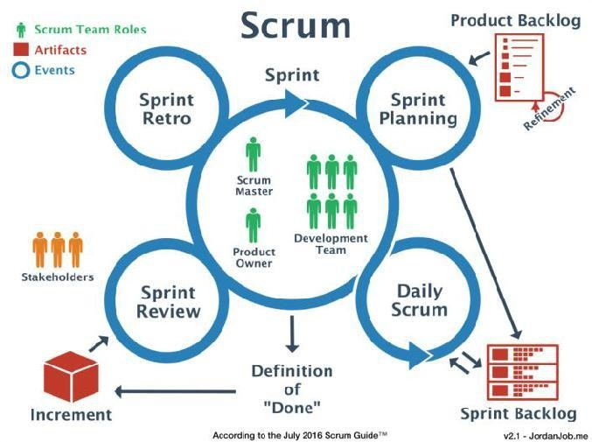

Figure 2. 1 Agile Technology

Sprints are iterations that may typically last from two to six weeks and the working product is demonstrated to client at end of each 'Sprint'. This helps minimize overall risk, and let the project adapt to changes quickly. The goal is to have an available release with working features at the end of each Sprint. Multiple iterations may be required to release a product or new features [7].

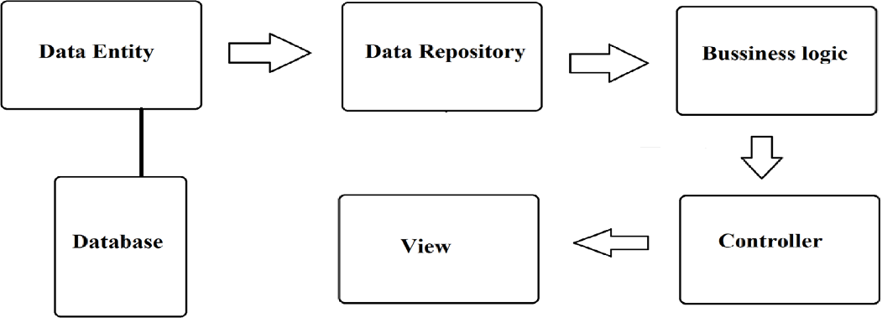

Figure 2.2 Internal Coding Architecture

Internal Coding Architecture provides architectural information of project. To develop system, we use .net framework based web application develop which contains views, controllers and app configurations. Entity shown in fig 2.2 Data entity, Data Repository and Business Logics are class libraries for data processing. Data Entity contains View- models of application. Data Repository contains methods, interfaces and models of application. Business Logic also contains methods and interfaces for dependency injection of data models.

### MILESTONES AND DELIVERABLES

Milestones are identified in order to complete the entire project in the time duration. Milestones are identified for every module of project. Once we examine that the project is feasible, we undertook project planning [3].

Table 2.1 Milestones and Deliverables

|  |  |  |
| --- | --- | --- |
| MILESTONES | DELIVERABLES | PURPOSE |
| Software installation and understanding of technology | Had complete  knowledge of visual studio for installation and user  experience. | To be familiar with android development. |
| System feasibility study, requirement and analysis. | Functional specification, Non-Functional Specification | It gives exact understanding of the System |
| System Design | Class Diagram Sequence Diagram Use case Diagram  Activity Diagram | It gives the logical structure that describes the system |
| Coding and unit testing | Individually tested and | It gives the required |

|  |  |  |
| --- | --- | --- |
| and correction if any | functional models. | Module |
| Integration and System Testing | The output obtains for the requirement functionality after implementation | Integration system is ready. |

### ROLES AND RESPONSIBILITIES

Mainly there are three roles:

* + - * **Database Administrator: -** He will handle all the operations related to database.
      * **Backend Developer: -** He will handle all the operations related to backend of web application.
      * **Frontend Developer: -** He will handle all the operations related to frontend of web application.

### GROUP DEPENDENCY

The members of the project should be dedicated to the project and should in turn help each other in whatever problems concerning the project. They should report periodically to the project leader or the concerned faculty for the project reporting [3].

### PROJECT SCHEDULING CHART

Table 2.2 Project Scheduling Chart

|  |  |  |  |  |
| --- | --- | --- | --- | --- |
| **No** | **TASK NAME** | **START**  **DATE** | **FINISH**  **DATE** | **DURATION** |
| 1 | Feasibility  study | 27/01/2020 | 01/02/2020 | 1 week |
| 2 | Requirement Gathering and Analysis on gathered  requirements | 03/02/2020 | 15/02/2020 | 2 weeks |
| 3 | Designing | 17/02/2020 | 29/02/2020 | 2 weeks |
| 4 | Core Coding | 02/03/2020 | 14/03/2020 | 2 weeks |
| 5 | Actual Coding | 16/03/2020 | 28/03/2020 | 2 weeks |
| 6 | Testing and  Maintenance | 30/03/2020 | 13/04/2020 | 2 week |
| 7 | Documentation | 13/04/2020 | 20/04/2020 | 1 week |

# SYSTEM REQUIREMENT STUDY

## STUDY OF CURRENT SYSTEM

There are only few web portals available which provides functionality as our web application. One of the best advantage of our portal is product purchasement security, manually verified buyers & sellers and 100% secured buyer’s & seller’s information (Like order details, personal details, user’s cart details etc.).

## PROBLEMS AND WEAKNESS OF CURRENT SYSTEM

* + - Current systems do not support return and replacement of products.
    - Current systems do not provide functionality to cancel pre-requested orders.
    - Current systems do not support payment gateway for product purchasement.
    - Current systems do not provide functionality to share product details to others.
    - Current systems do not provide user contact/complaint forum.

## USER CHARACTERISTICS

* + - **Admin: -** Admin can manage roles, user scopes, product details, categories details, location details, event details, product purchasement requests, add product requests, add event requests, product purchasement status, manual user verification, configure settings, can see logs and reports.
    - **Login User: -** Login user can interact with portal, purchase product according to their choice of category and location. Login user can request to promote own product (add own product), request to add new event and also continuously check status of requested for purchase a product.
    - **Guest User: -** Guest user can also interact with portal like login user except purchasing products. To purchase product guest user must be register self. Guest user can request to promote own product (add own product) and request to add new event also.

## HARDWARE AND SOFTWARE REQUIREMENTS

### HARDWARE REQUIREMENTS

* + - * Microsoft Windows 7/8/10 installed computer.
      * At least 4 GB of RAM.
      * At least 1 GB of hard disc space.

### SOFTWARE REQUIREMENTS

* + - * Visual studio Community 2017
      * SQL server 2017
      * IIS Server
      * Web browser (Chrome/Explorer/Mozilla Firefox)

## ASSUMPTIONS AND DEPENDENCY

### Assumptions:

* + - User has some knowledge of interaction of website
    - User has internet connectivity

### Dependency:

* + - The application working is needed good internet connectivity.

# SYSTEM ANALYSIS

## REQUIREMENTS OF NEW SYSTEM

### USE CASE DIAGRAMS

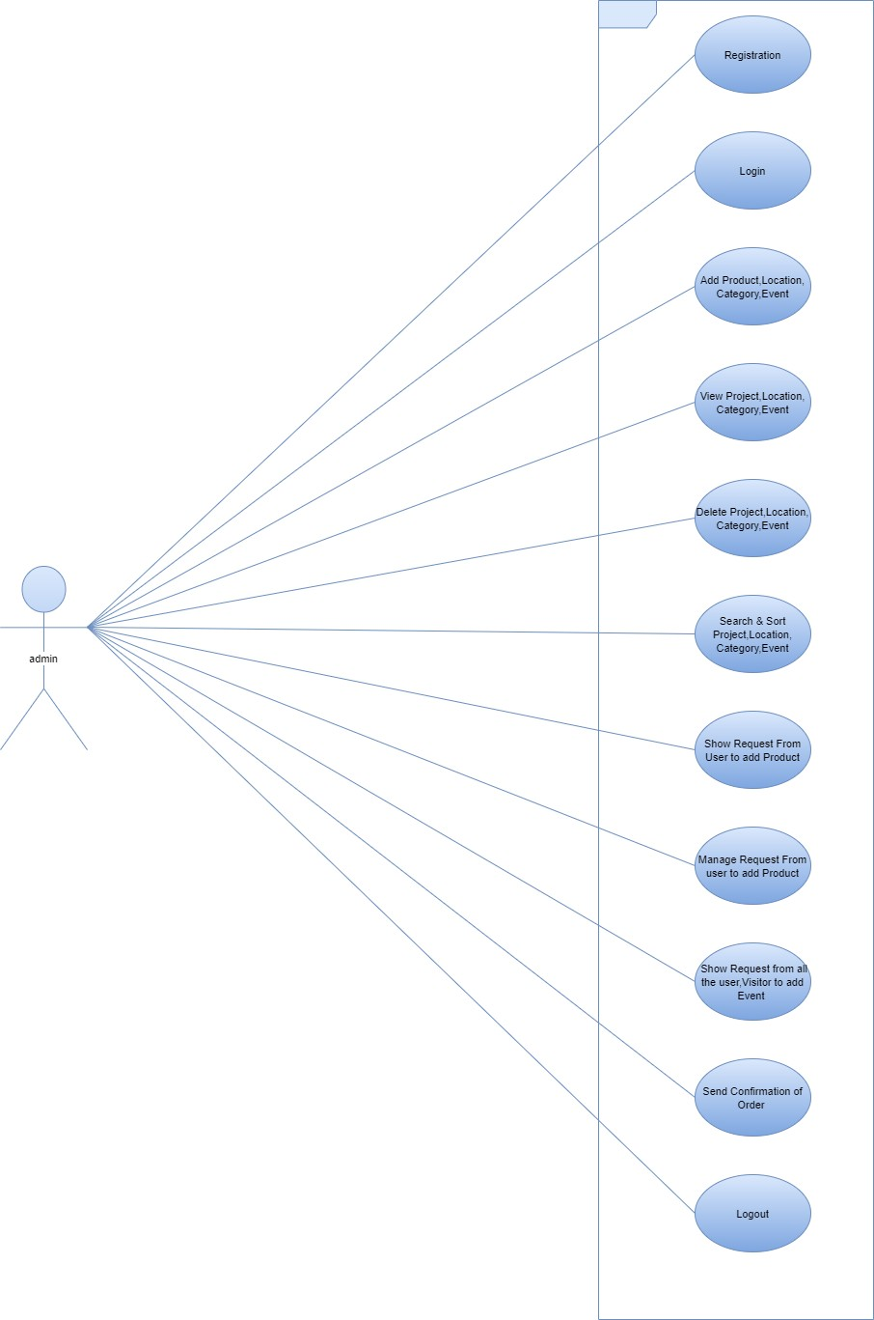

Figure 4.1 Use Case Diagram for Admin [8]

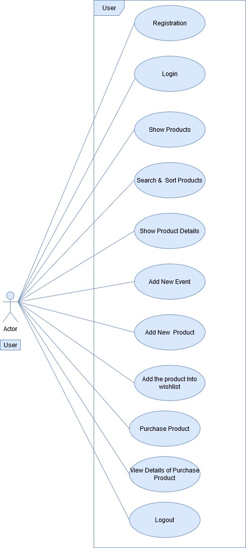

Figure 4.2 Use Case Diagram for Registered User [8]

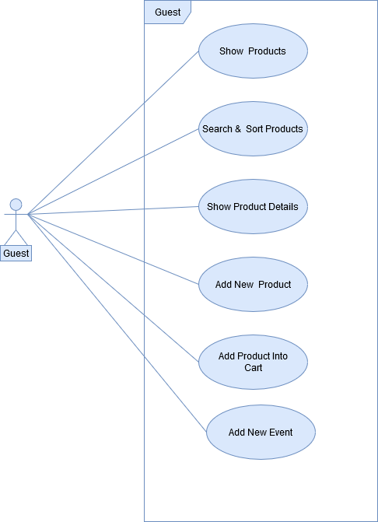

Figure 4.3 Use Case Diagram for Visitor (Guest User) [8]

### SYSTEM REQUIREMENTS

* 1. **Login**

**I/P:** Email and Password

**Process:** Match email and password with stored database

**O/P:** If credentials match than user is redirected to dashboard

### Admin

* + 1. **Create/Manage Products I/P:** Product details

**Process:** Store details in database

**O/P:** Success or failure message

* + 1. **Create/Manage Registered Users I/P:** Registered User details **Process:** Store details in database **O/P:** Success or failure message
    2. **Create/Manage Product Categories I/P:** Category details

**Process:** Store details in database

**O/P:** Success or failure message

* + 1. **Create/Manage Product Locations I/P:** Location details

**Process:** Store details in database

**O/P:** Success or failure message

* + 1. **Create/Manage Events I/P:** Event details

**Process:** Store details in database

**O/P:** Success or failure message

* + 1. **Manage Product Purchasement Requests I/P:** Product Purchasement details **Process:** Store details in database

**O/P:** Success or failure message

* + 1. **Manage Add Product Requests I/P:** Product details

**Process:** Store details in database

**O/P:** Success or failure message

### Manage Add Event Requests

**I/P:** Event details

**Process:** Store details in database

**O/P:** Success or failure message

* + 1. **Manage Product Purchasement Status I/P:** Product Purchasement details **Process:** Store details in database

**O/P:** Success or failure message and reflect into purchasement status

* + 1. **Manage User Verification (Manually) I/P:** Event details

**Process:** Store details in database and manually verify user details

**O/P:** Success or failure message

* + 1. **Manage System Settings I/P:** System settings

**Process:** Update system setting configurations

**O/P:** Success or failure message

* + 1. **Manage Logs and Reports I/P:** Start date and end date

**Process:** generate report from database

**O/P:** Report and logs for admin in txt file

### R.3: Registered User

* + 1. **Purchase Product According to their choice of Categories and Locations**

**I/P:** Product details

**Process:** Check product available or not in database

**O/P:** Success or failure message

### Add Product to Cart According to their choice of Categories and Locations

**I/P:** Product details

**Process:** Store details in database

**O/P:** Success or failure message

### Promote Own Product (request to add new product) into Portal I/P: Product details

**Process:** Store details in database and verify product details by admin

**O/P:** Success or failure message

* + 1. **Request to Add New Event into Portal I/P:** Event Details

**Process:** Store details in database and verify event details by admin

**O/P:** Success or failure message

* + 1. **Check Status of requested to Purchase Product I/P:** Product Purchasement Status

**Process:** Check product purchasement status into database and reflect into user product purchasement status

**O/P:** Product Purchasement Status

### Visitor(Guest) User

* + 1. **Add Product to Cart According to their choice of Categories and Locations**

**I/P:** Product details

**Process:** Store details in database

**O/P:** Success or failure message

* + 1. **Promote Own Product (request to add new product) into Portal I/P:** Product and User details

**Process:** Store details in database and verify product details by admin

**O/P:** Success or failure message

* + 1. **Request to Add New Event into Portal I/P:** Event and User Details

**Process:** Store details in database and verify event details by admin

**O/P:** Success or failure message

## FEATURES OF NEW SYSTEM

* + - Easy to use
    - Reliable
    - Time saving
    - Secure

## SYSTEM ACTIVITY

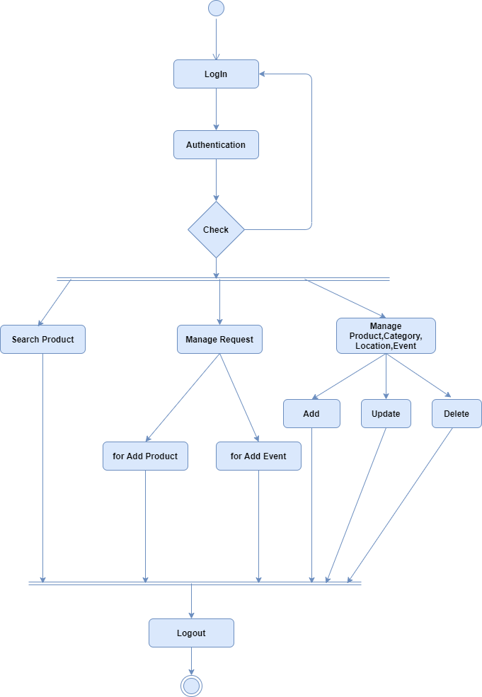

Figure 4.4 Activity of Admin [8]

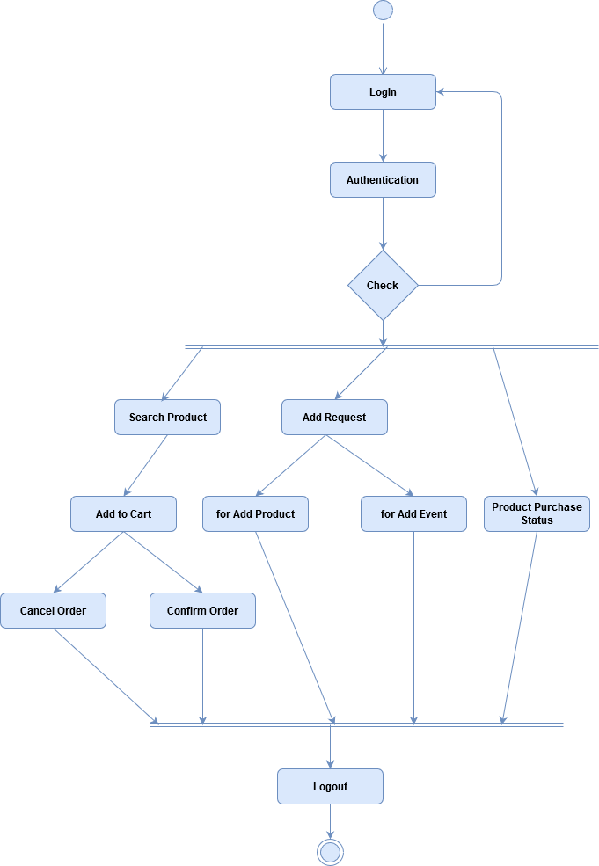

Figure 4.3 Activity of Registered User [8]

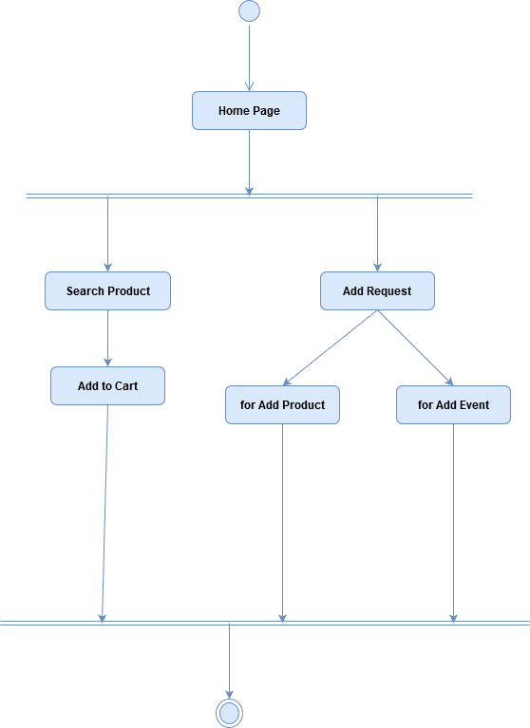

Figure 4.4 Activity of Visitor (Guest) User [8]

# SYSTEM DESIGN

## SYSTEM ARCHITECTURE DESIGN

### Data Flow DIAGRAM

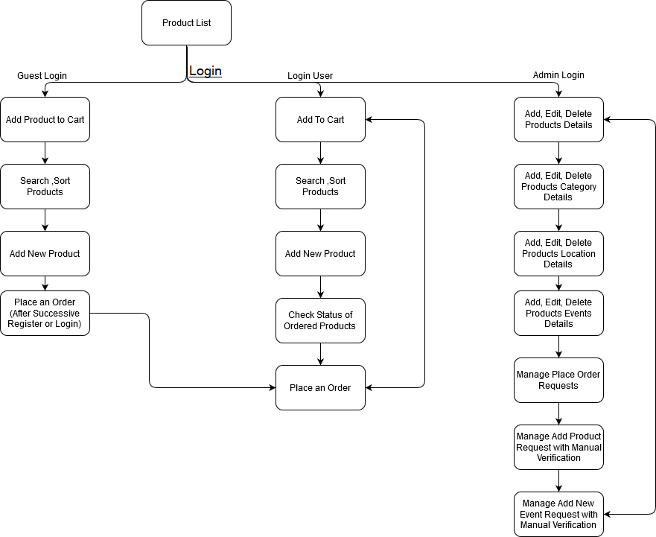

Figure 5.1 Data Flow Diagram [8]

### CLASS DIAGRAM

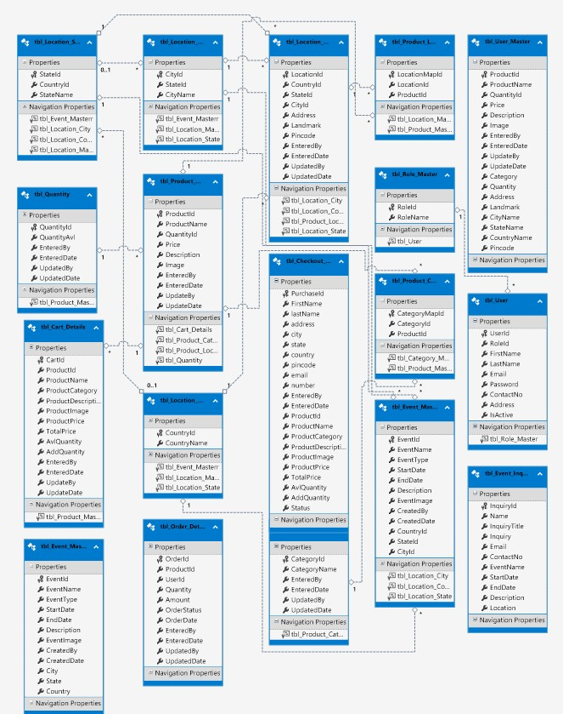

Figure 5.2 Class Diagram [8]

### SEQUENCE DIAGRAM

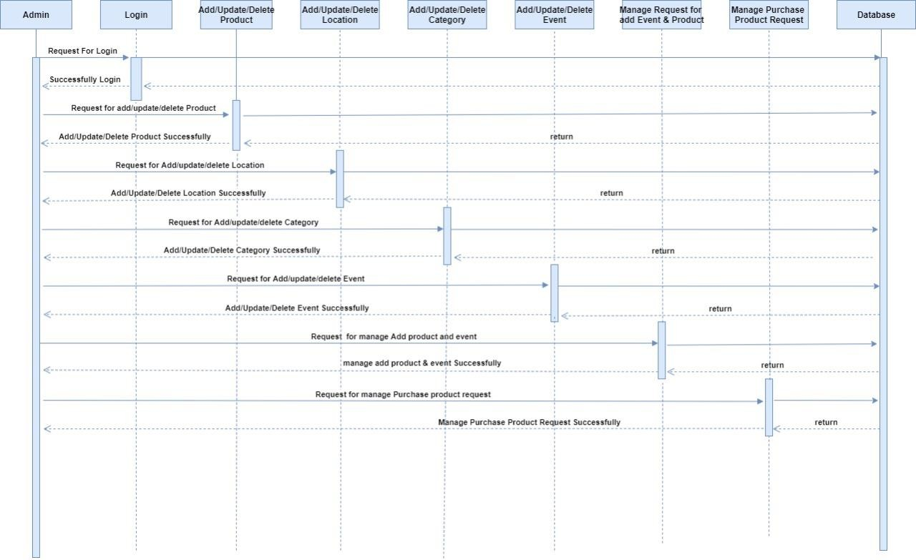

Figure 5.3 Sequence diagram for Admin [8]

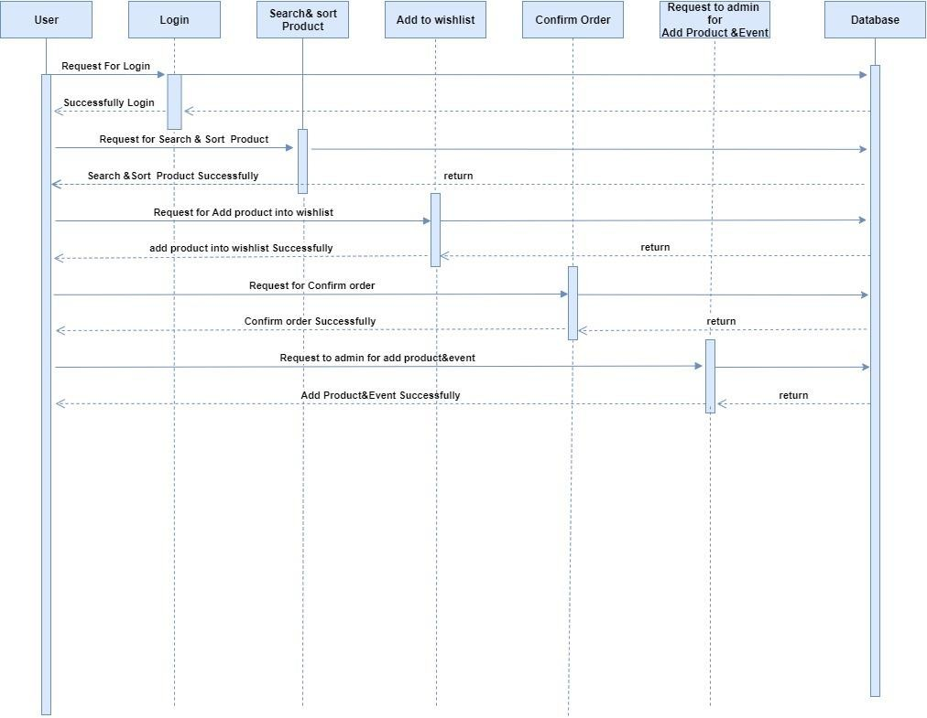

Figure 5.4 Sequence diagram for Registered User [8]

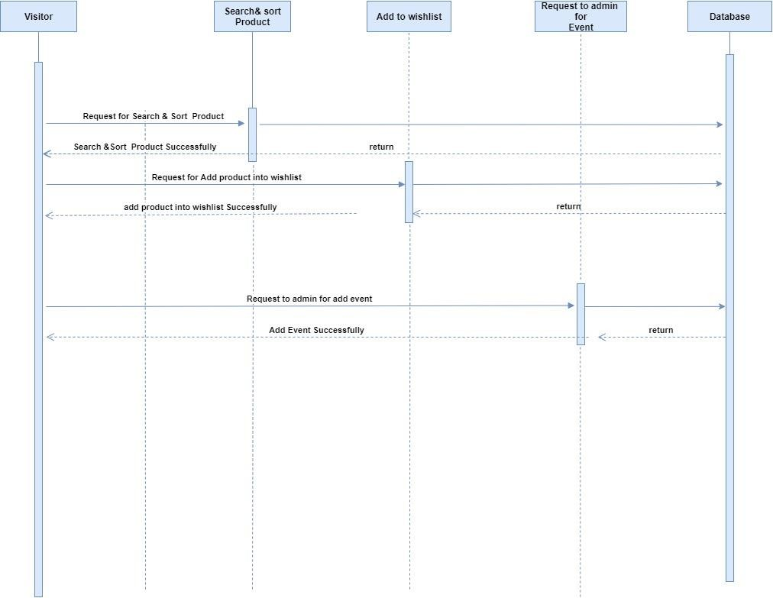

Figure 5.5 Sequence diagram for Visitor (Guest) User [8]

## DATABASE DESIGN

### TABLE AND RELATIONSHIP



Figure 5.6 Table Relation Schema

### DATA DICTIONARY

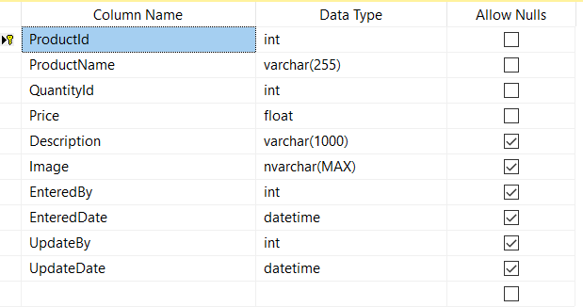

Figure 5.7 Product Data Dictionary

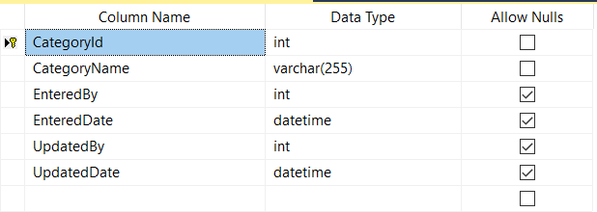

Figure 5.8 Category Data Dictionary

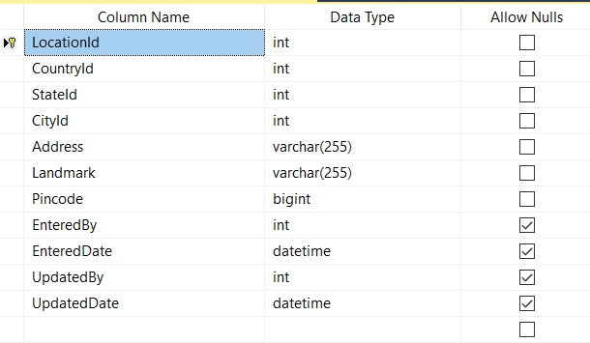

Figure 5.9 Location Data Dictionary

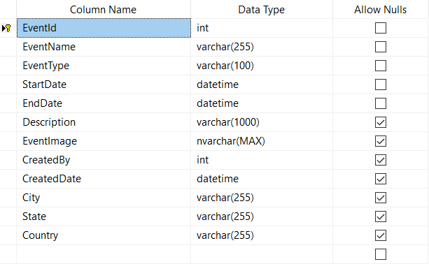

Figure 5.10 Event Data Dictionary

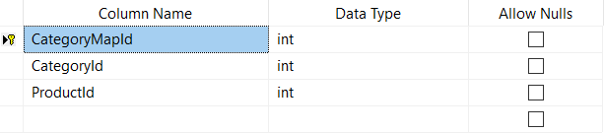

Figure 5.11 Product-Category Map Data Dictionary

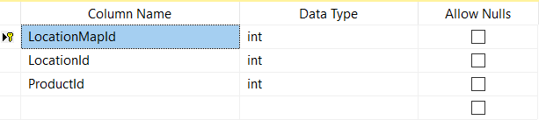

Figure 5.12 Product-Location Map Data Dictionary

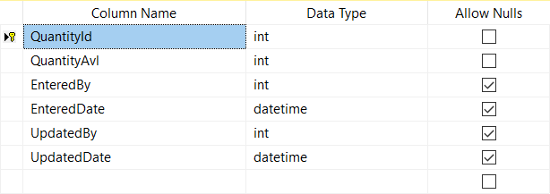

Figure 5.13 Product-Quantity Data Dictionary

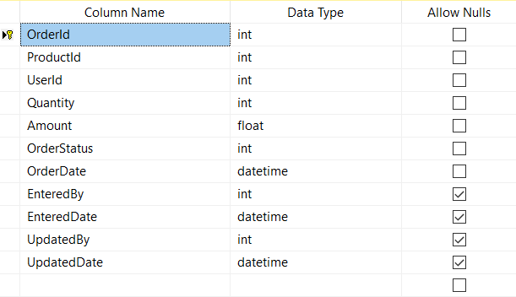

Figure 5.14 Order Details Data Dictionary

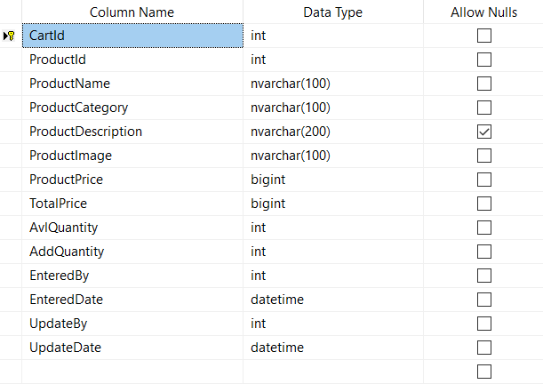

Figure 5.15 Product-Cart Details Data Dictionary

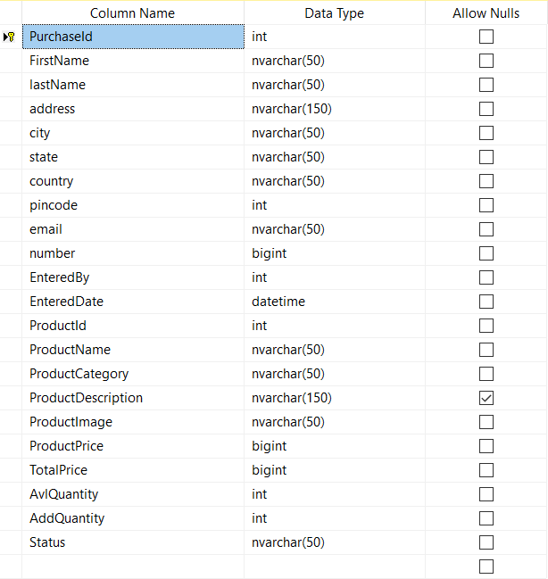

Figure 5.16 Product-Checkout Details Data Dictionary

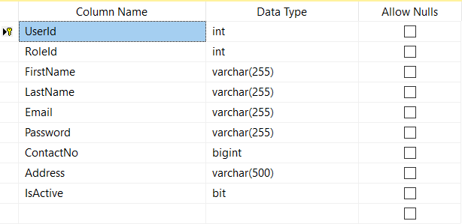

Figure 5.17 User Details Data Dictionary

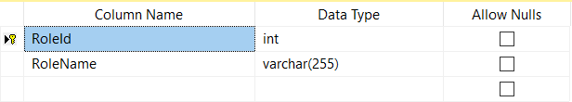

Figure 5.18 User-Roles Data Dictionary

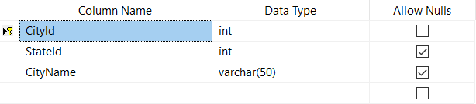

Figure 5.19 Location-City Details Data Dictionary

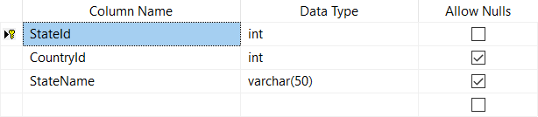

Figure 5.20 Location-State Details Data Dictionary

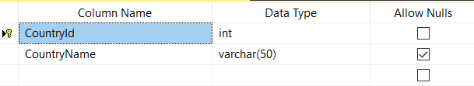

Figure 5.21 Location-Country Details Data Dictionary

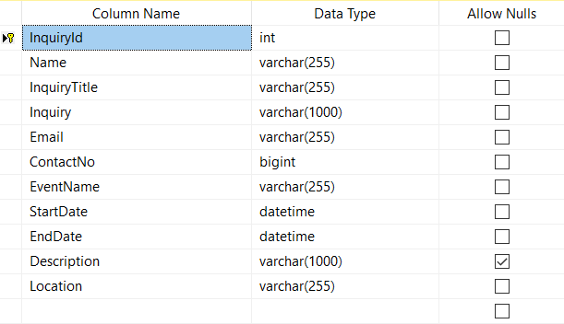

Figure 5.22 Event-Inquiry Data Dictionary

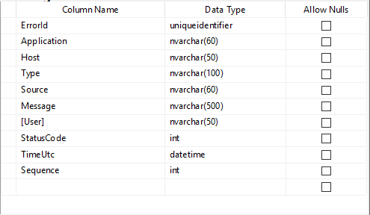

Figure 5.23 Error Log Data Dictionary

# IMPLEMENTATION PLANNING

## IMPLEMENTATION ENVIRONMENT

**Multi-User vs Single-User**

Single user applications are the application where it is useful to only one user at a time. While in Multi user application is going to use by many users at the same time and thus Web application are used by many users at the same time. Our system is a Multi-user system as we have more than one user who can use the system at a same time [4].

**GUI vs NON-GUI**

Non-GUI application uses command Prompt for input and output while GUI application has graphics form to interface and other graphics property for various I/O operation and are easy to use. Our System is a GUI based and thus easy and effective to use therefore user can easily give input and take Output [4].

With my experience of implementation at various sites of similar systems, I found that the skill level on computers and processes varies on a wide range at various levels and also at the same level among officers. Also, the drive and motivation of the guide heading the particular would really boost the implementation and ensure that the activities are completed on time and execution would be faster [4].

## MODULES SPECIFICATION

This Project has been divided into three modules for making its implementation faster.

* + 1. Admin Dashboard
    2. Registered User Portal
    3. Guest User Portal

1. **Admin Dashboard Specifications**
   * Manage user regarding roles, user accessibility and system configurations.
   * Manage application data regarding product, categories, locations and events details.
   * Manage requests regarding add new product, add new event and purchase products.
   * Manage product purchasement status and user verification(manually).
   * Admin has full access to check app logs and reports of user access.
2. **Registered(Login) User Portal Specifications**
   * Registered User can add product to cart and purchase product according to their choice of category and location from portal.
   * Registered User can request to add new product and also can request to add new event.
   * Registered User can check status of requested for purchase a product.
3. **Guest User Portal Specifications**
   * Guest User can add product to cart and can interact with portal like login user except purchasing products. To purchase product guest user must be register self.
   * Guest User can request to add new product and also can request to add new event.
   1. **CODING STANDARD**

Coding Standards contribute to an improved comprehension of source code. Perhaps one of the most influential aids to understanding the logical flow of an application is how the various elements of the application are named. A name should tell “what” rather than “how.” By avoiding names that expose the underlying implementation, which can change, you preserve a layer of abstraction that simplifies the complexity. Naming Conventions make programs more understandable by making them easier to read. They can also give information about the function of the identifier for example, whether it’s a constant, class, etc. which can be helpful in understanding the code [5].

Reasons for using the coding standards are

1. Uniform distribution
2. Encourages good programming skills

All code should be well commented. All procedures and functions should begin with a comment to explain what the function/procedure performs.

* + Good and meaningful comments make code more maintainable.
  + Do not write comments for every line of code and every variable defined
  + Write comments wherever required. But good readable code will require very less comments. If all the variables and methods names are meaningful, that would make the code very readable and will not need more comments

# TESTING

Testing is a vital part during the course of software development. Testing helps us understand the flaws in the system and hence enhance the system for a better user experience. In the course of software development testing usually occupies anywhere between 20-40 % of the effort and resources. Software testing is both a discipline and a process. Though software testing is part of the software development process, it should not be considered part of software development. It is a separate discipline from software development. Software development is the process of coding functionality to meet defined end- user needs. Software testing is an iterative process of both validating functionalities, and, even more important, attempting to break the software. The iterative process of software testing consists of [6]:

* + - Designing tests
    - Executing tests
    - Identifying problems
    - Getting problems fixed of the effort and resources.

## TESTING PLAN

The testing sub-process includes the following activities in a phase dependent manner:

* + - Create Test Plans.
    - Create Test Specifications.
    - Review Test Plans and Test Specifications.
    - Conduct tests according to the Test Specifications, and log the defects.
    - Fix defects, if any.
    - When defects are fixed continue from activity.

## TESTING STRATEGY

### Module Testing:

In a system each module in developed individually and each module is tested separately and the result is integrated. We have tested each small module like switching on the screen and switching it off again [6].

### Integration Testing:

It is clear that certain errors, which are related to the integration of different program modules, cannot be detected by unit testing. Such errors only are detected by an integrated test. The process by which individual modules are put together to realize major sub sections and functions of a program is known as a system integration.

When tests are performed which exercises interfaces among modules this is known as integration. The number of instructions coded and tested or the number of functions or modules implemented and tested often measures the progress of IT [6].

### Regression Testing:

After we made some changes in one module, we had to check whether older modules were working perfectly or not.

## TESTING METHODS

### White Box Testing

White-box Testing is a method of testing software that tests internal structures or workings of an application, as opposed to its functionality in white-box testing an internal perspective of the system, as well as programming skills, are used to design test cases. The tester chooses inputs to exercise paths through the code and determine the appropriate outputs. This is analogous to testing nodes in a circuit, e.g.in-circuit testing (ICT) [6].

White-box testing can be applied at the unit, integration, and system levels of the software testing process [6].

Although traditional testers tended to think of white-box testing as being done at the unit level, it is used for integration and system testing more frequently today. It can test paths within a unit, paths between units during integration, and between subsystems during a system– level test. Though this method of test design can uncover many errors or problems, it has the potential to miss unimplemented parts of the specification or missing requirements [6].

### Black Box Testing

Black-box testing is a method of software testing that examines the functionality of an application without peering into its internal structures or workings (see white-box testing). This method of test can be applied to virtually every level of software testing: unit, integration, system and acceptance. It typically comprises most if not all higher-level testing, but can also dominate unit testing as well [6].

### Code Cover

The way to make sure that you have got all the control flow covered is to cover all the paths in the program during the testing (via white-box testing). This implies that both branches

are exercised for an ‘if’s statement, all branches are exercised for a case statement, the loop is taken once or multiple times as well as ignored for a while statement an all components of complicated logical expressions are exercised. This is called Path Testing. Branch Testing reports whether entire Boolean expression tested in control structures evaluated to both true and false.

Additionally, it includes coverage of switch statement cases, exception handlers and interrupts handlers. Path testing includes branch testing as it considers all possible combination of individual branch conditions. A

simpler version is Statement Testing which determines if each statement in the program has been executed at least once. The coverage via Path Testing includes the coverage via Statement Testing. Since Path Testing is extremely comprehensive it is costly, hence a viable minimum should be measuring Statement Testing coverage [6].

## TEST CASES

Table 7.1 Login & Register Module

|  |  |  |  |
| --- | --- | --- | --- |
| **TEST CASE** | **TEST SCENARIO** | **EXPECTED RESULT** | **PASS/FAIL** |
| 01 | Filling all the mandatory fields in  login | Redirect to the dashboard | PASS |
| 02 | Invalid login credentials | Error message displayed | PASS |
| 03 | Keeping any field  empty during login | Error message  displayed | PASS |
| 04 | Filling all the mandatory fields in registration | Redirect to the login | PASS |
| 05 | Invalid registration credentials | Error message displayed | PASS |
| 06 | Keeping any field empty during  registration | Error message displayed | PASS |

Table 7.2 Admin Dashboard Module

|  |  |  |  |
| --- | --- | --- | --- |
| **TEST CASE** | **TEST SCENARIO** | **EXPECTED RESULT** | **PASS/FAIL** |
| 01 | Create Products, Locations,  Categories and Events | Add details to database | PASS |
| 02 | Edit Products, Locations,  Categories and Events | Update details to database | PASS |
| 03 | Delete Products, Locations, Categories and Events | Remove details from database | PASS |
| 04 | Generate Logs and  Reports | Show all logs and  reports | PASS |
| 05 | Update System Settings | Change application configurations | PASS |

Table 7.3 Registered User Portal Module

|  |  |  |  |
| --- | --- | --- | --- |
| **TEST CASE** | **TEST SCENARIO** | **EXPECTED RESULT** | **PASS/FAIL** |
| 01 | Add Product to Cart(Wish list) | Add details to database | PASS |
| 02 | Purchase a Product | Add purchase  details to database | PASS |
| 03 | Check Status of Product Purchasement | Return product purchasement status from database | PASS |
| 04 | Request to Add Product | Add details to database | PASS |
| 05 | Request to Add  Event | Add details to  database | PASS |
| 06 | Search Product By Categories and Locations | Return related products from database | PASS |
| 07 | On-click Product | Return details from  database | PASS |
| 08 | Generate Logs and Reports | Show all logs and reports | PASS |
| 09 | Log-out | Log-out from portal  & restrict to access. | PASS |

Table 7.4 Guest User Portal Module

|  |  |  |  |
| --- | --- | --- | --- |
| **TEST CASE** | **TEST SCENARIO** | **EXPECTED RESULT** | **PASS/FAIL** |
| 01 | Add Product to  Cart(Wish list) | Add details to  database | PASS |
| 02 | Request to Add Product | Add details to database | PASS |
| 03 | Request to Add Event | Add details to database | PASS |
| 04 | Search Product By Categories and  Locations | Return related products from  database | PASS |
| 05 | On-click Product | Return details from database | PASS |
| 06 | Generate Logs and Reports | Show all logs and reports | PASS |

# 8.0 USER MANUAL

A user guide or user's guide, also commonly known as a manual, is a technical communication document intended to give assistance to people using a particular system. It is usually written by a technical writer, although user guides are written by programmers, product or project managers, or other technical staff, particularly in smaller companies.

User guides are most commonly associated with electronic goods, web portals, computer hardware and software.

Our user guides contain both a written guide and the associated images. In the case of our application, it is usual to include screenshots of how the program should look. The language used is matched to the intended audience.

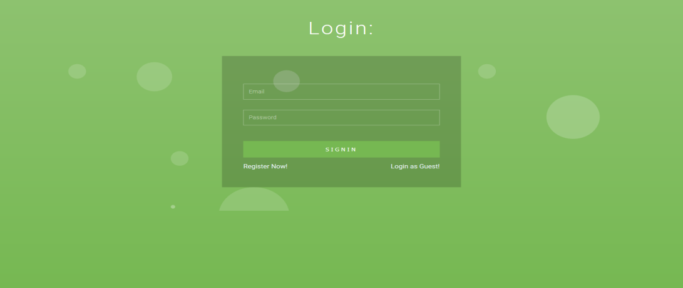

Figure 8.1 Login Page

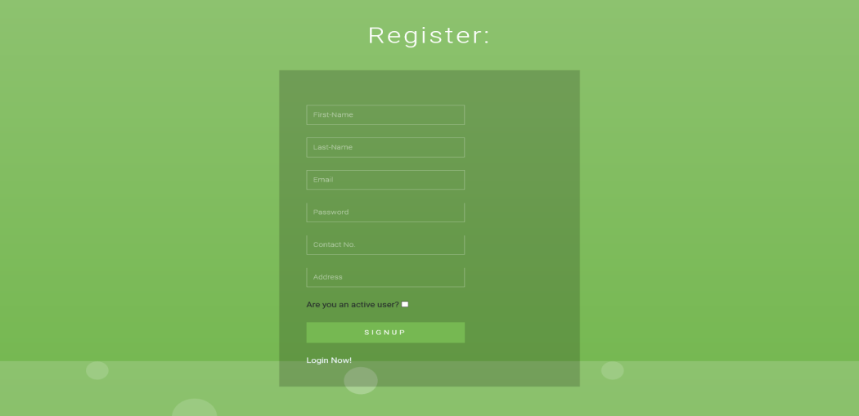

Figure 8.2 Registration Page

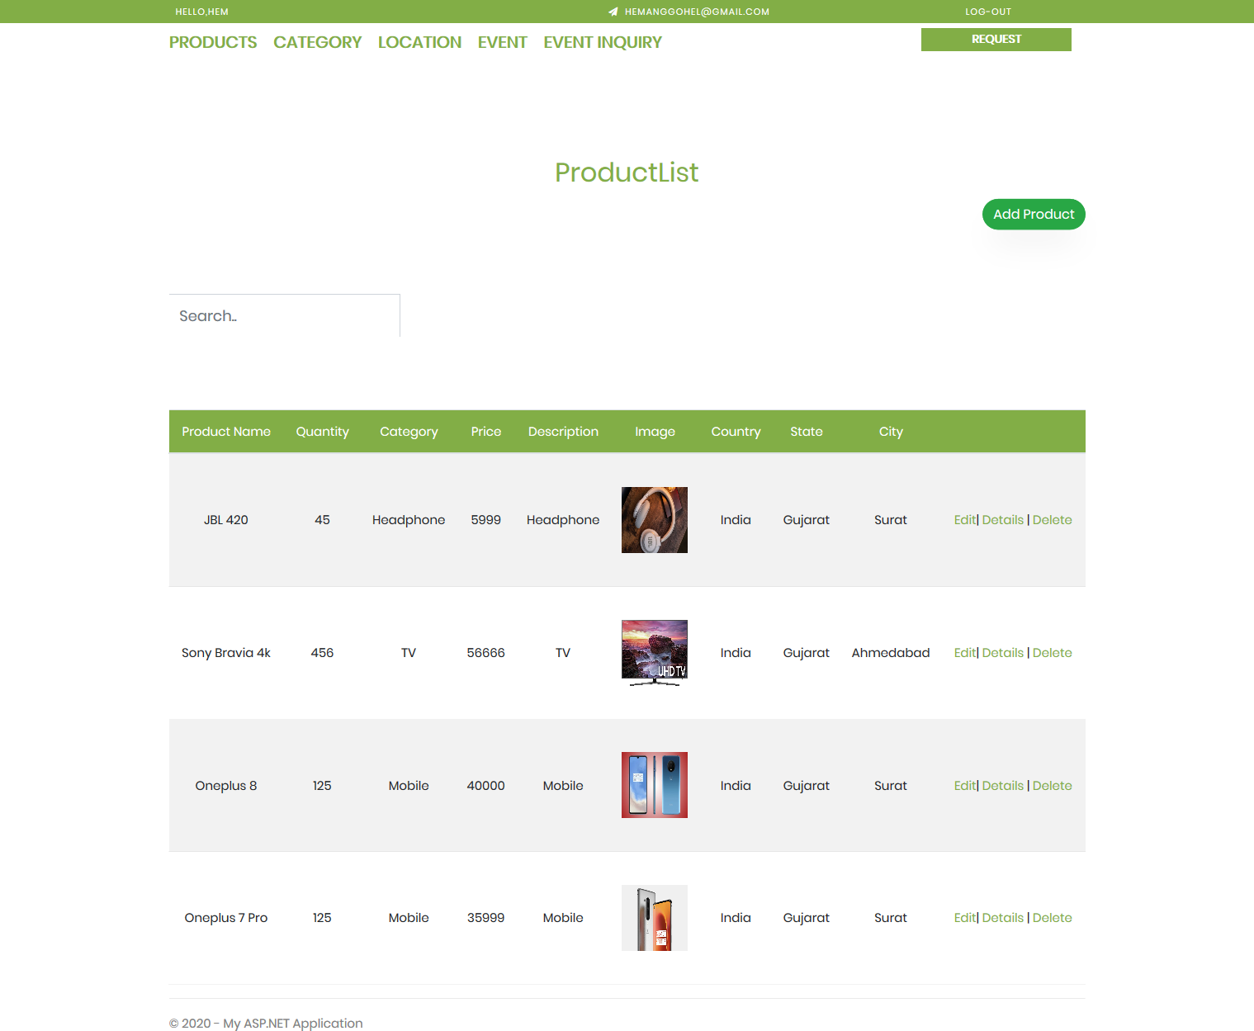

Figure 8.3 Admin Dashboard Page

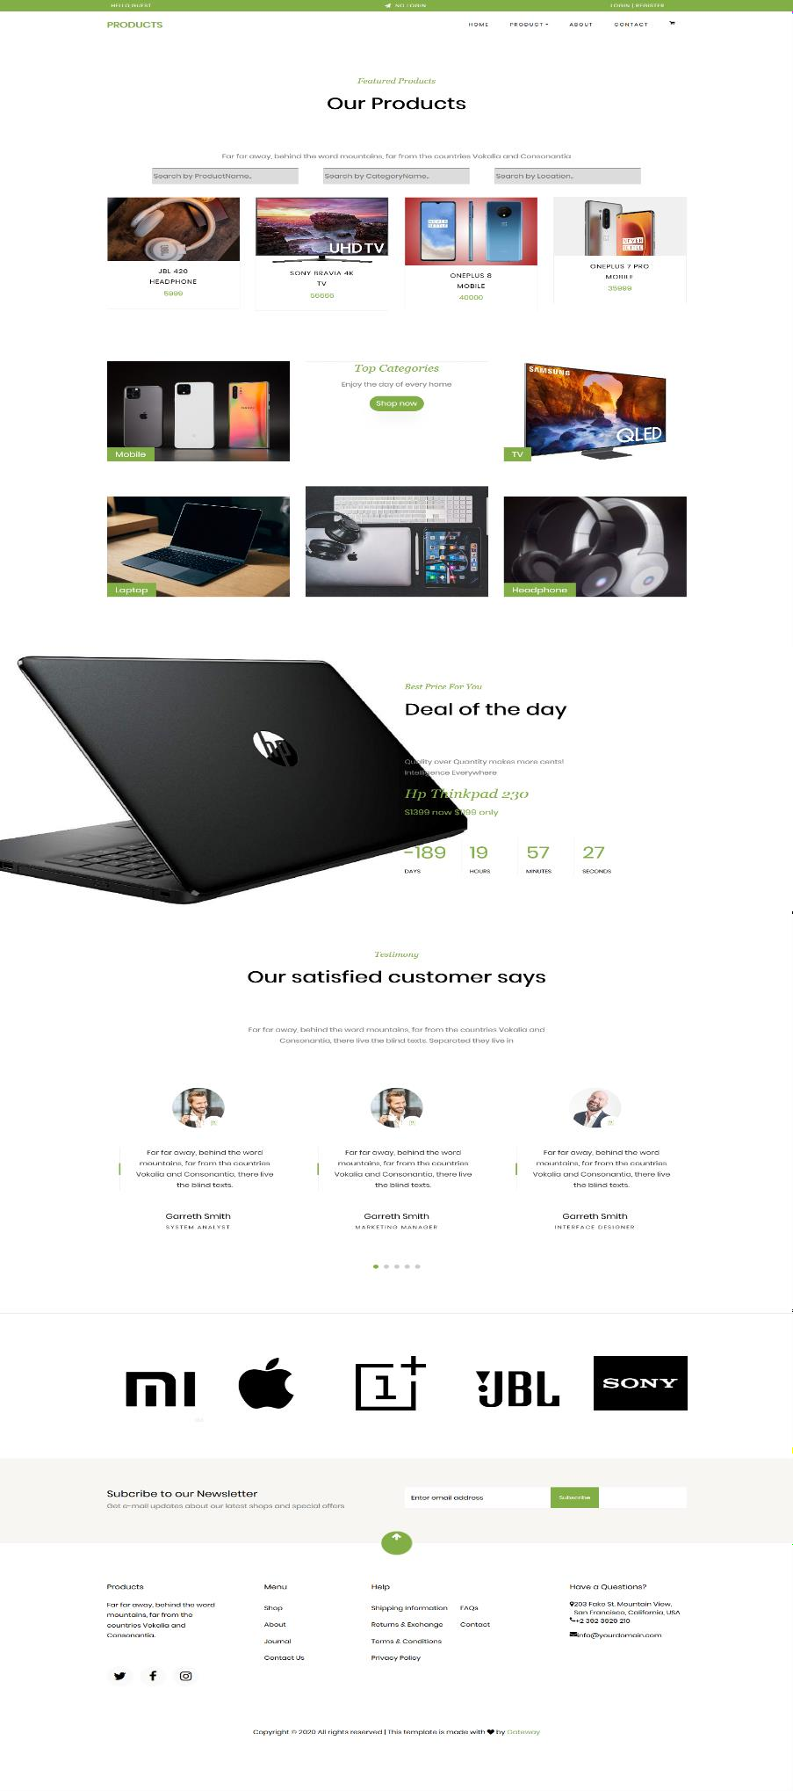

Figure 8.4 Product Portal Page

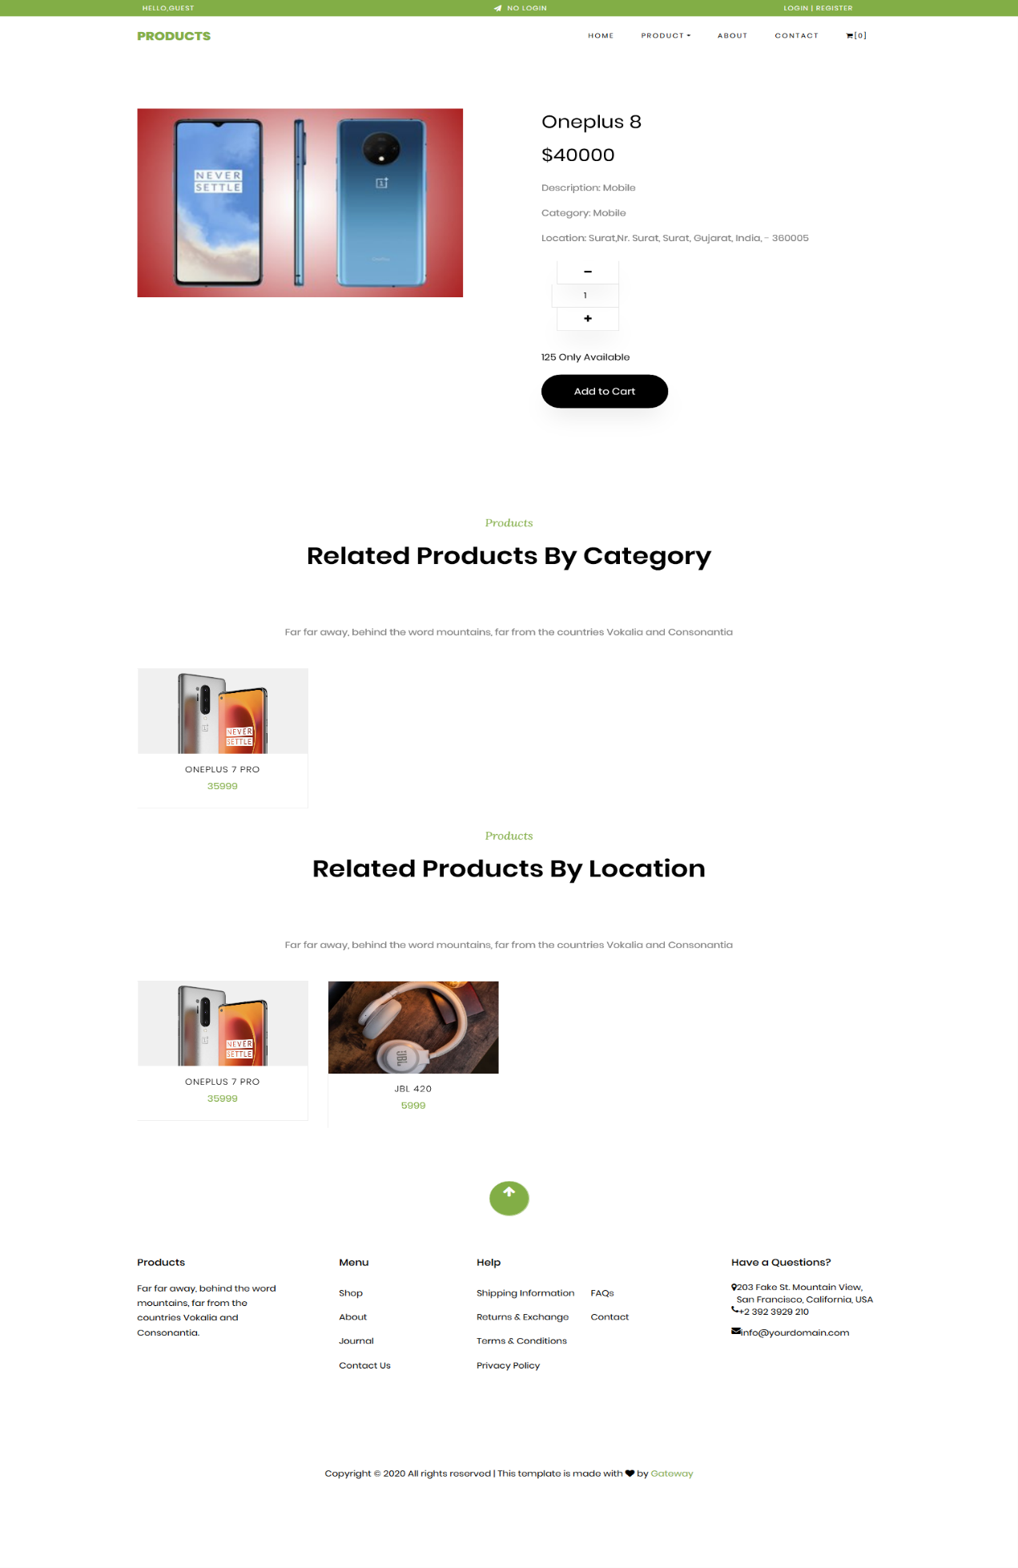

Figure 8.5 Product Details Page

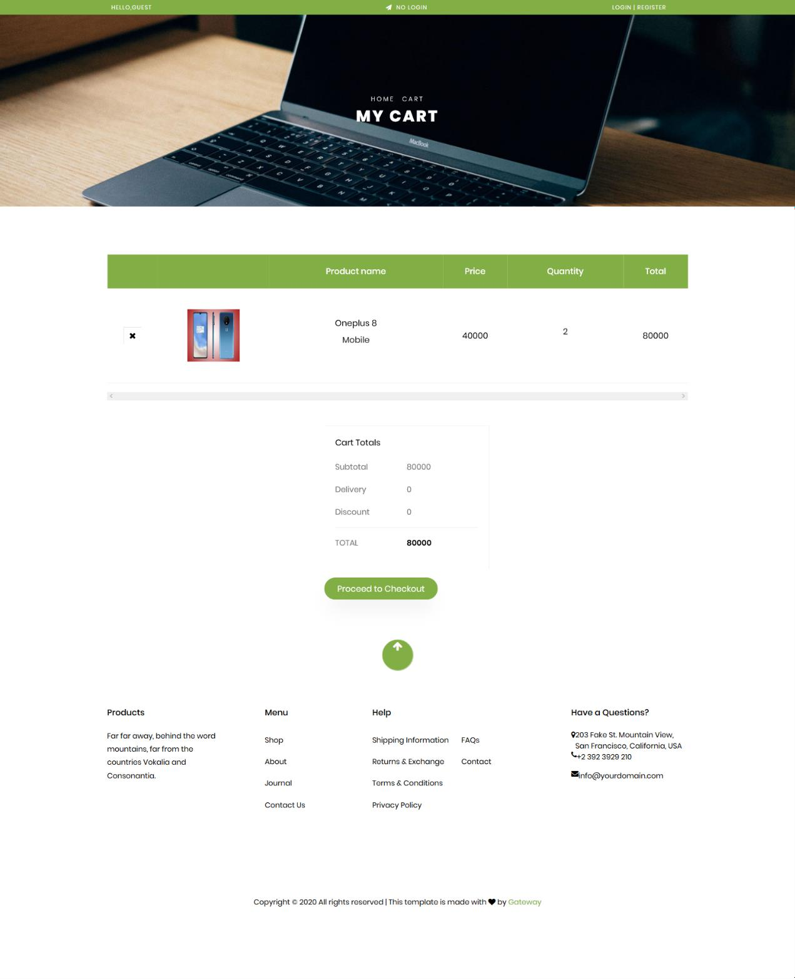

Figure 8.6 Product Cart Page

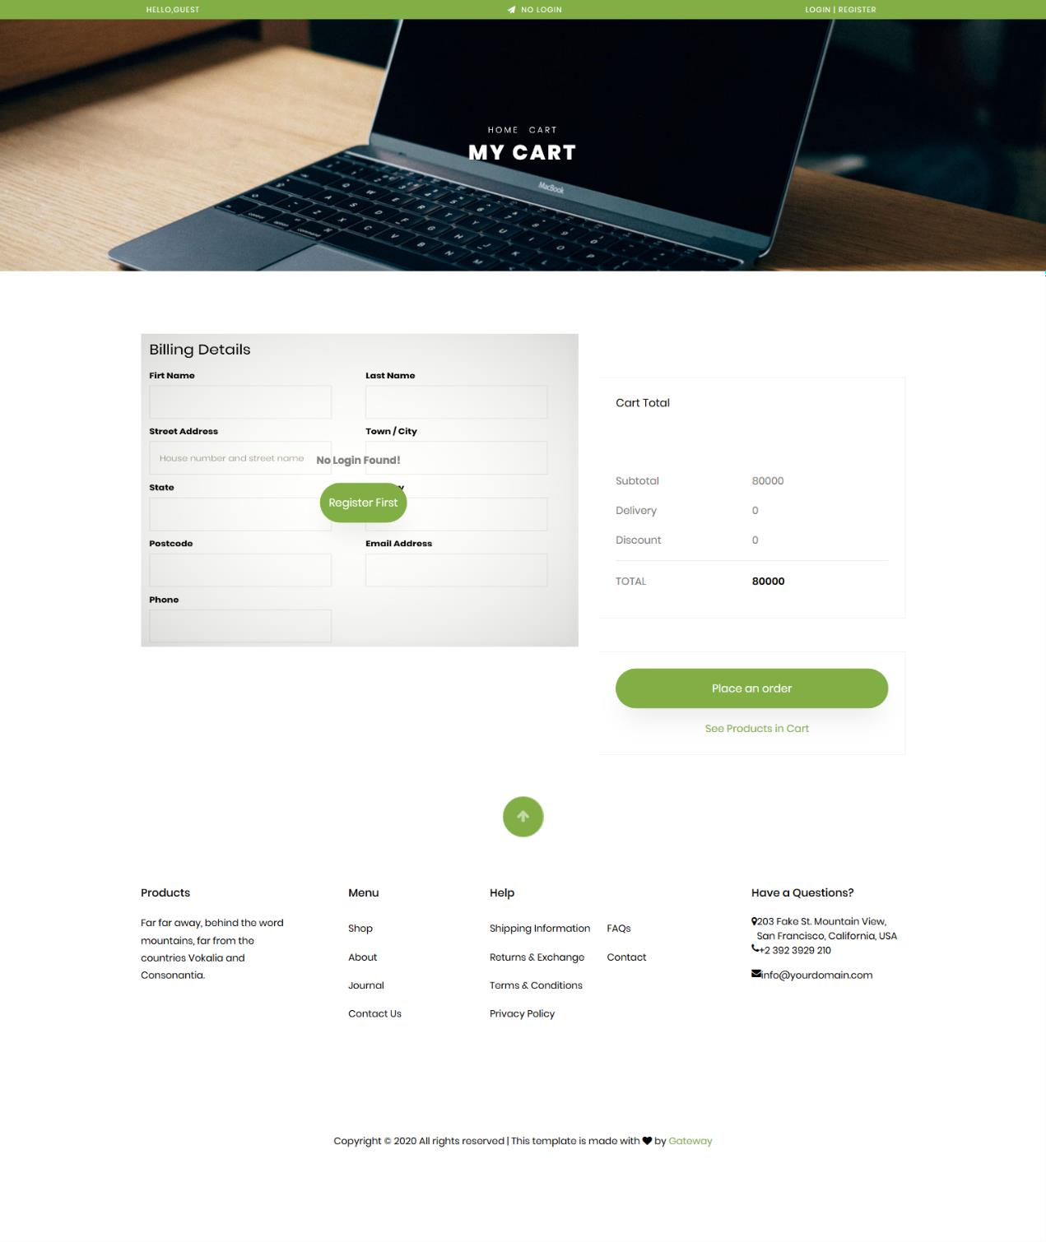

Figure 8.7 Product Checkout for Guest User Page

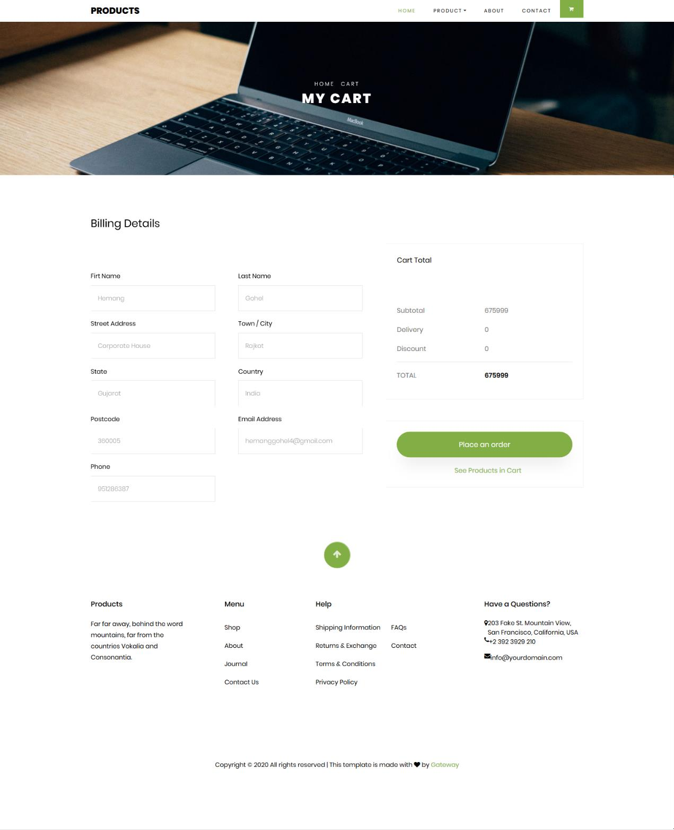

Figure 8.8 Product Checkout for Registered User Page

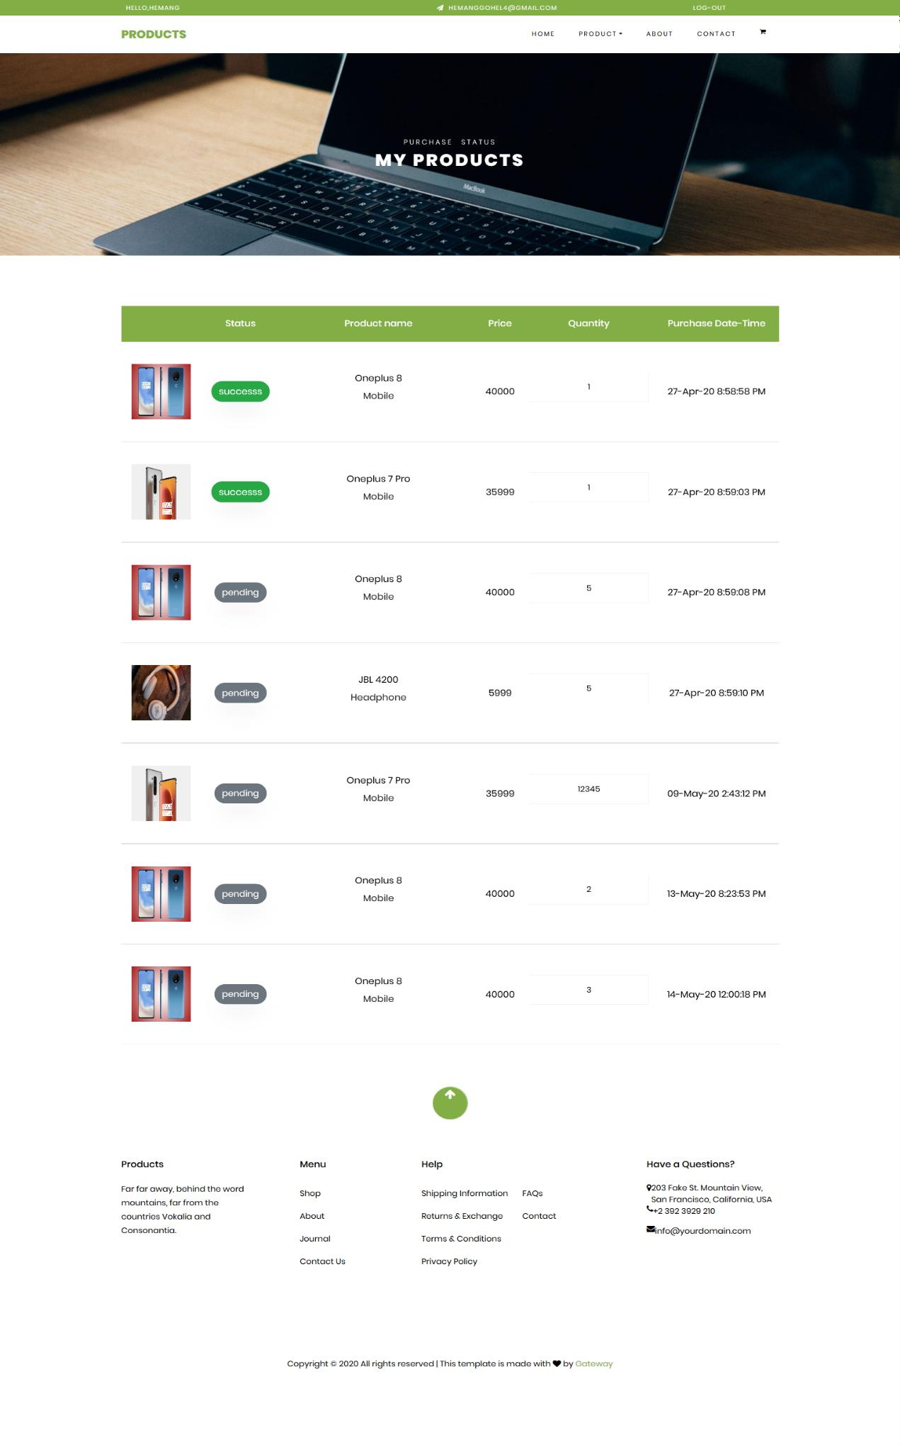

Figure 8.9 Product Purchasement Status Page

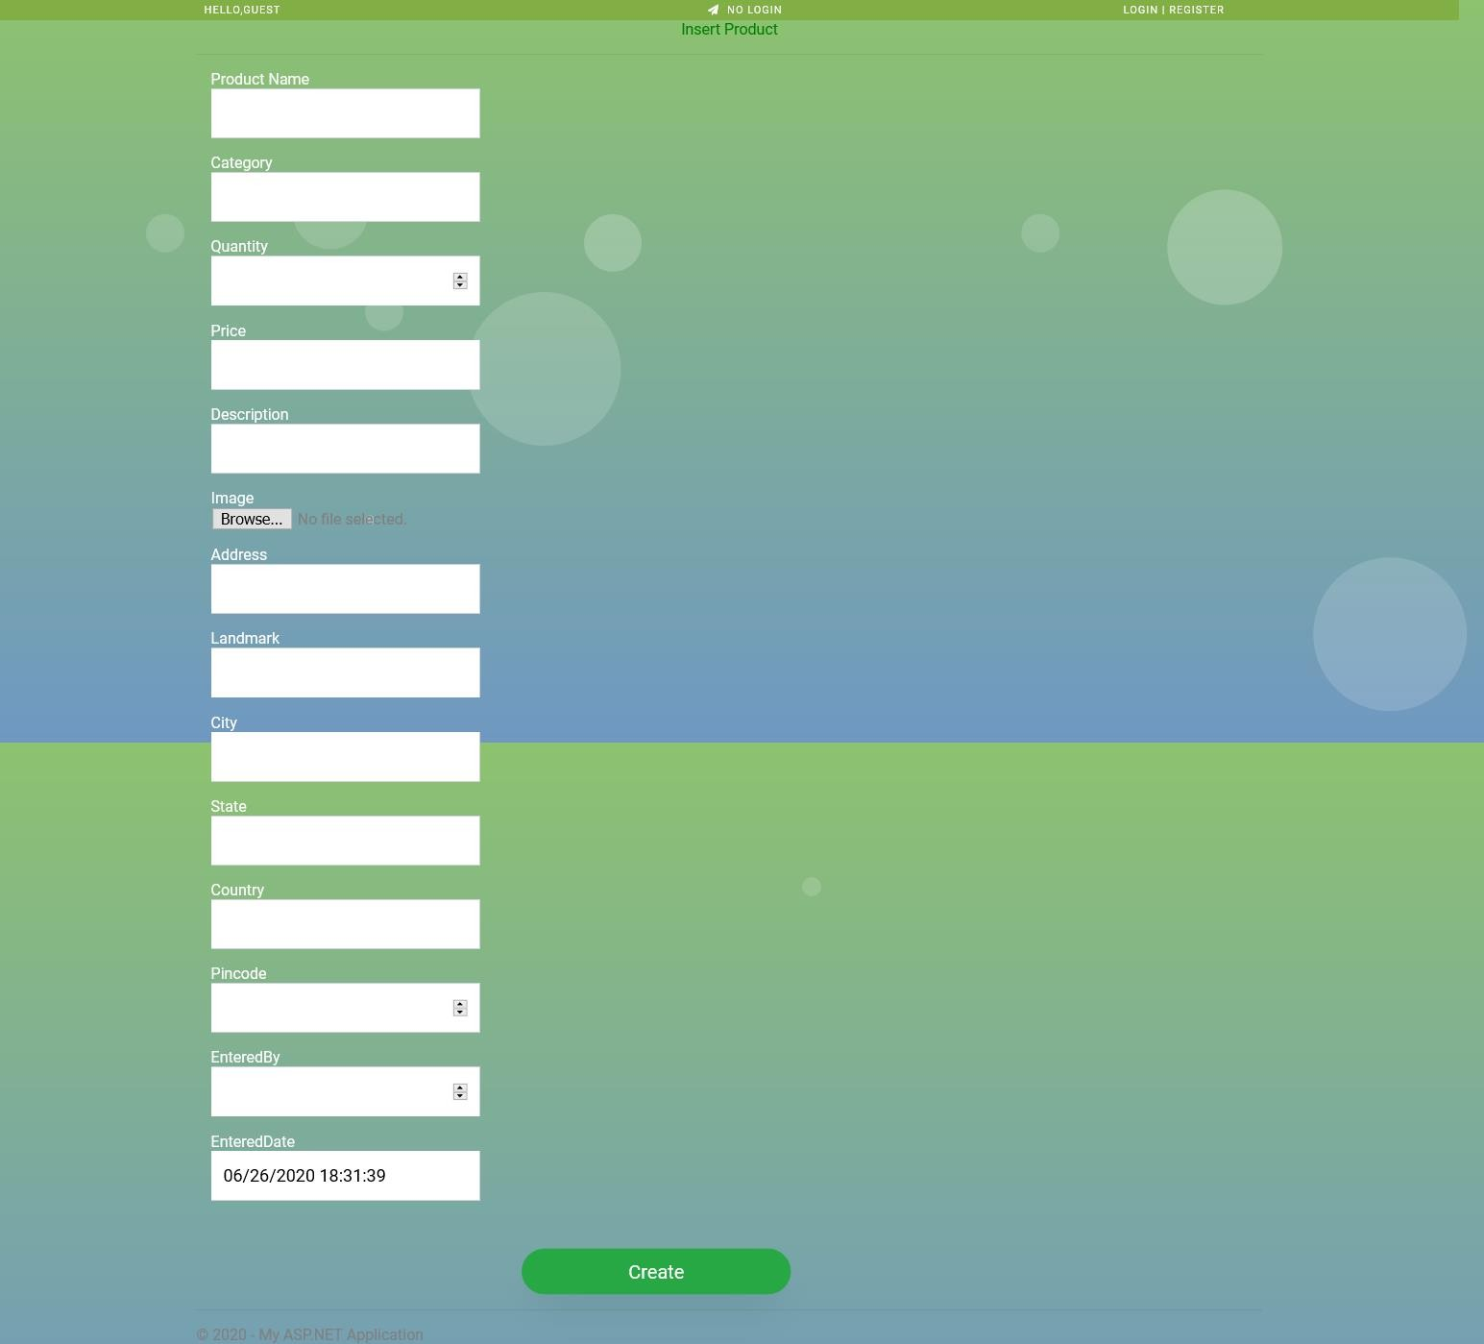

Figure 8.10 Request to Add New Product Page

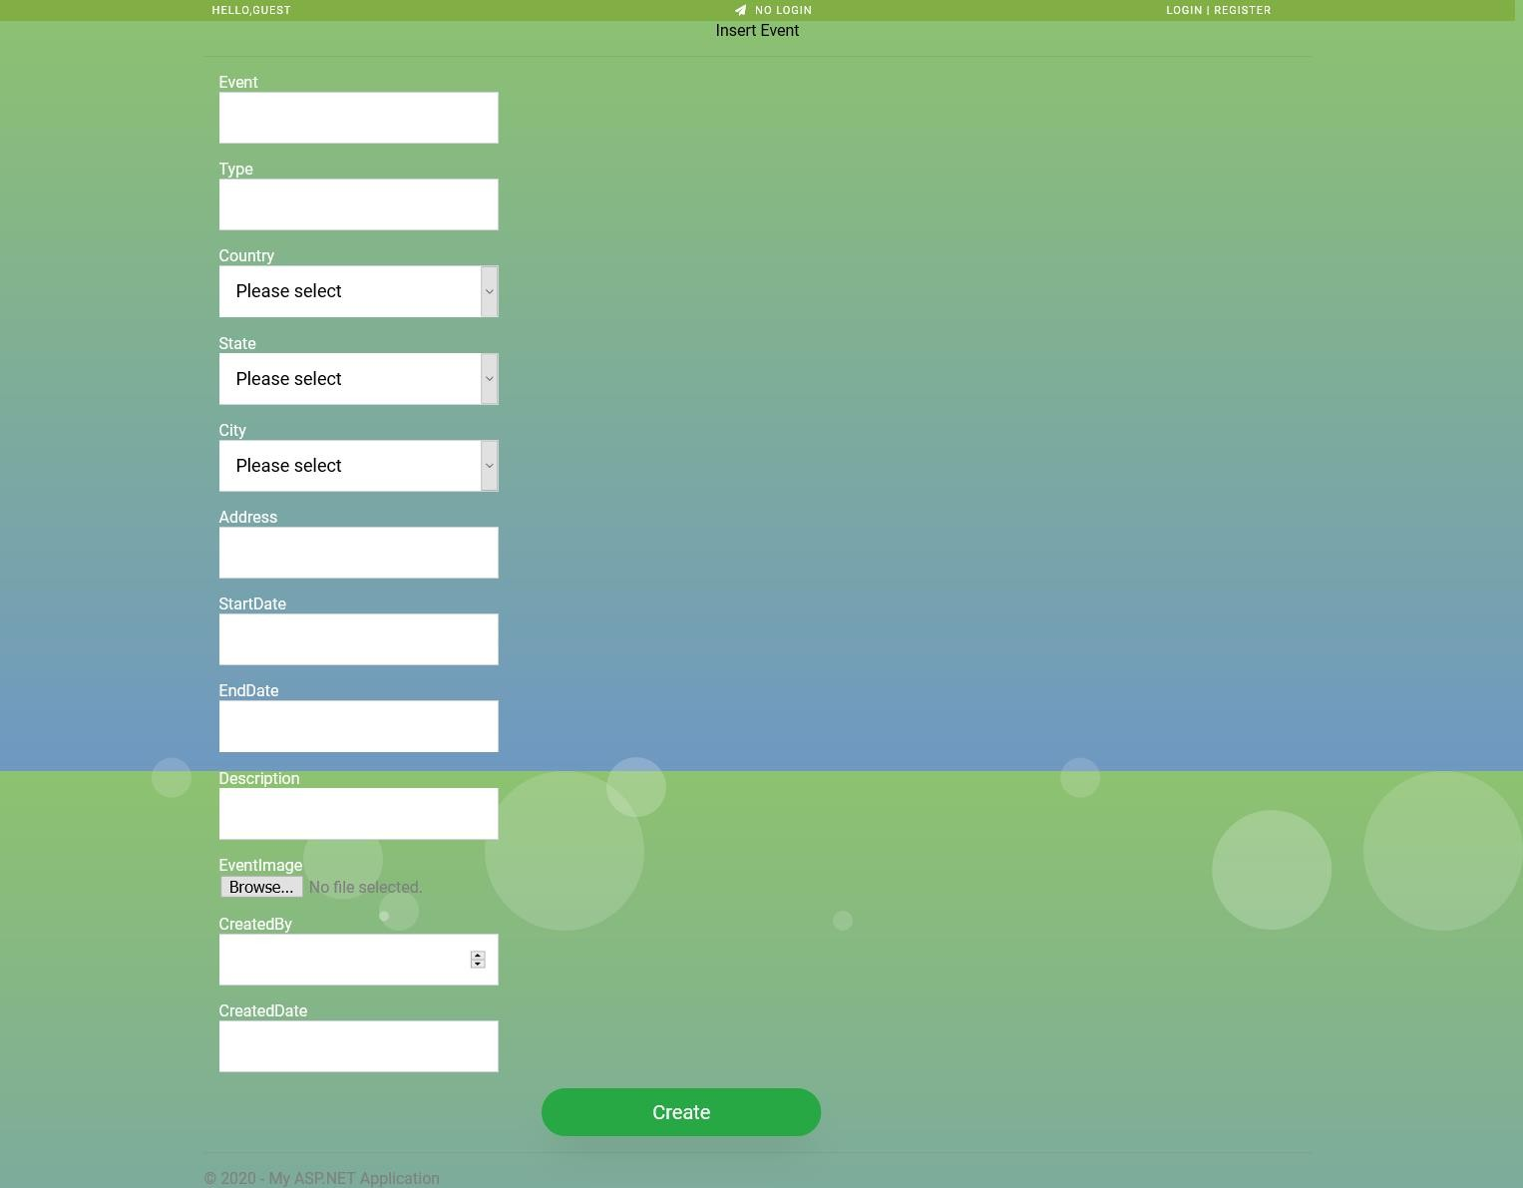

Figure 8.11 Request to Add New Event Page



Figure 8.12 Product-List with Edit, Details and Delete Page

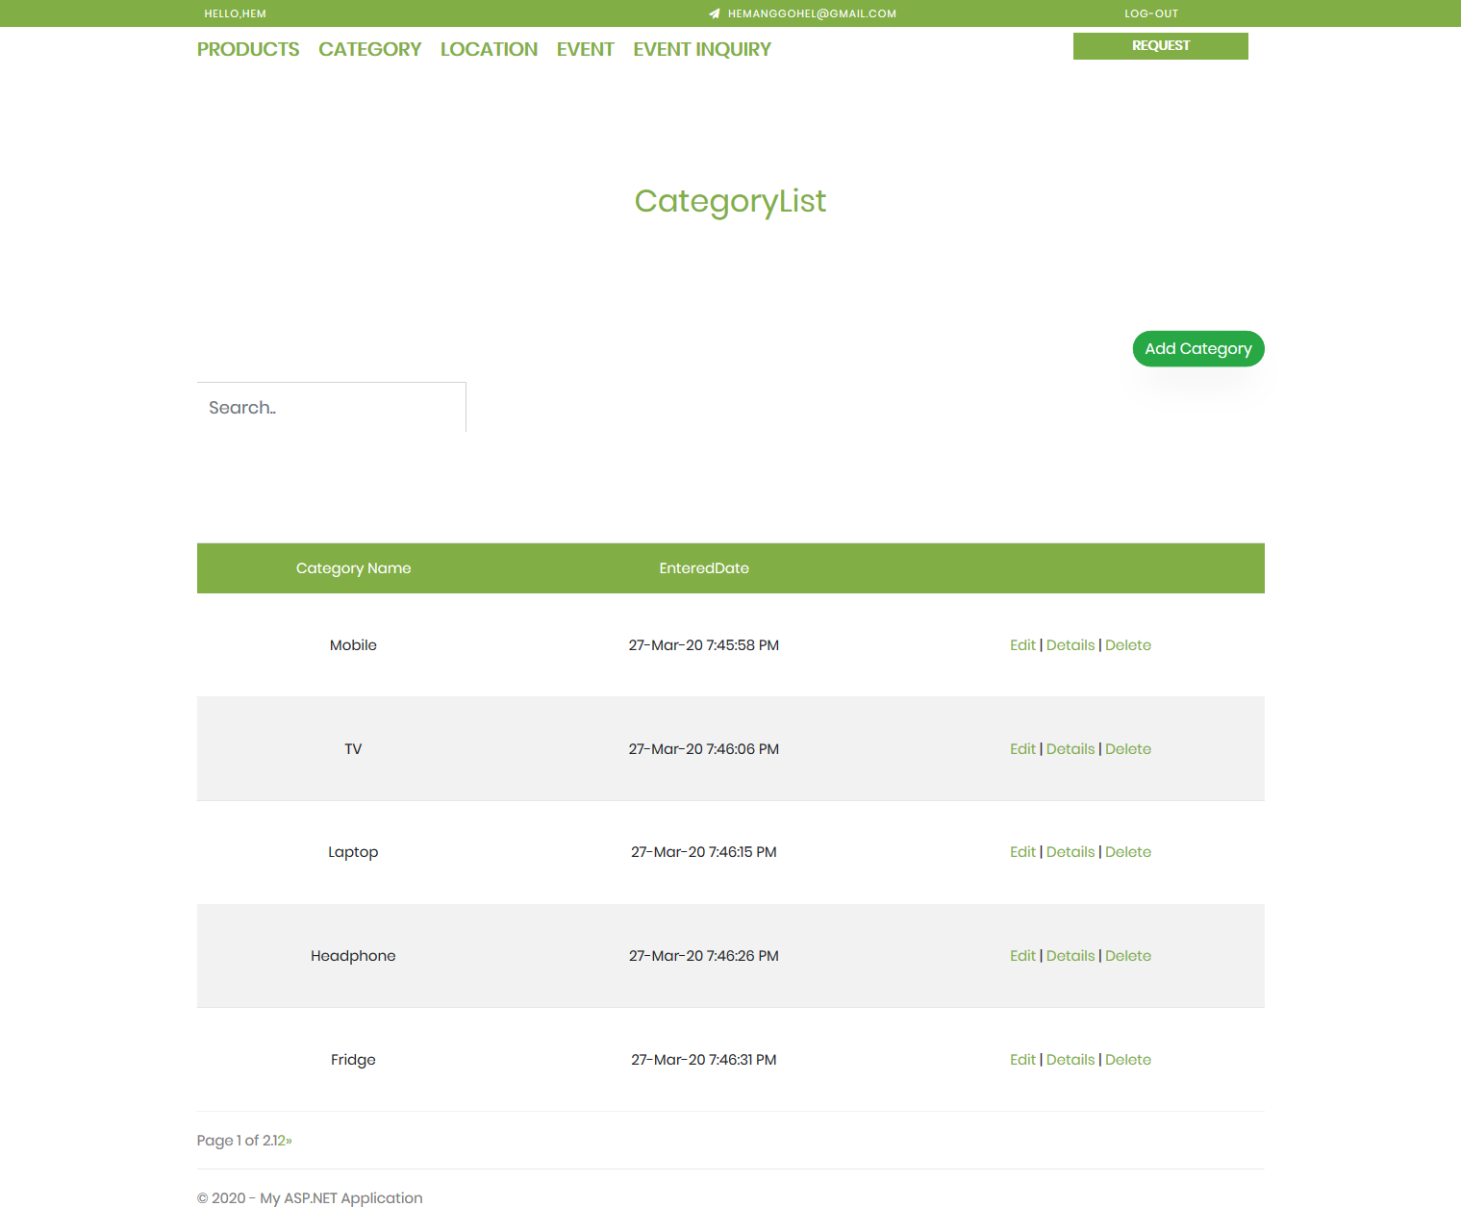

Figure 8.13 Category-List with Edit, Details and Delete Page

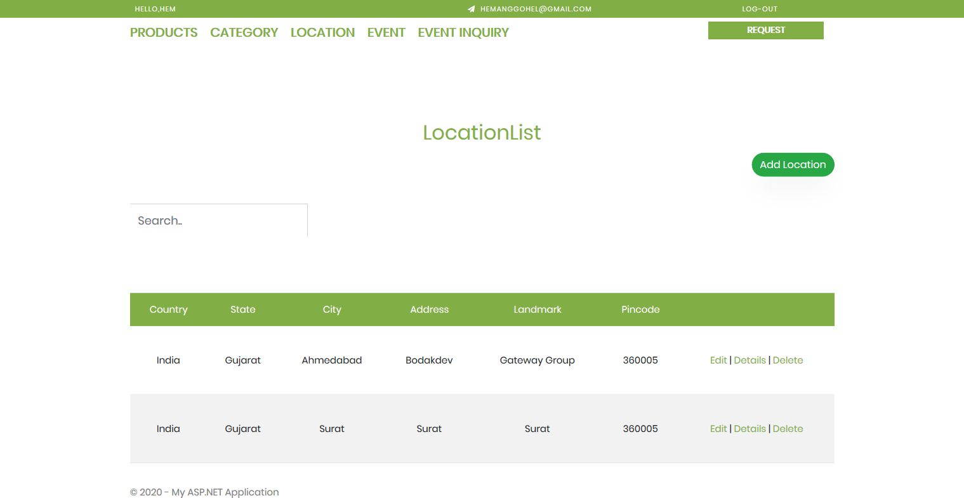

Figure 8.14 Location-List with Edit, Details and Delete Page

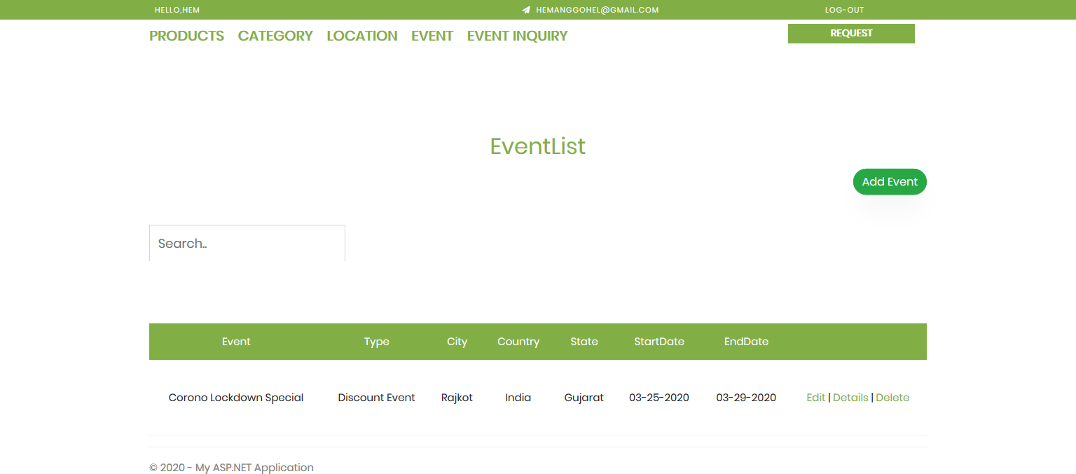

Figure 8.15 Event-List with Edit, Details and Delete Page

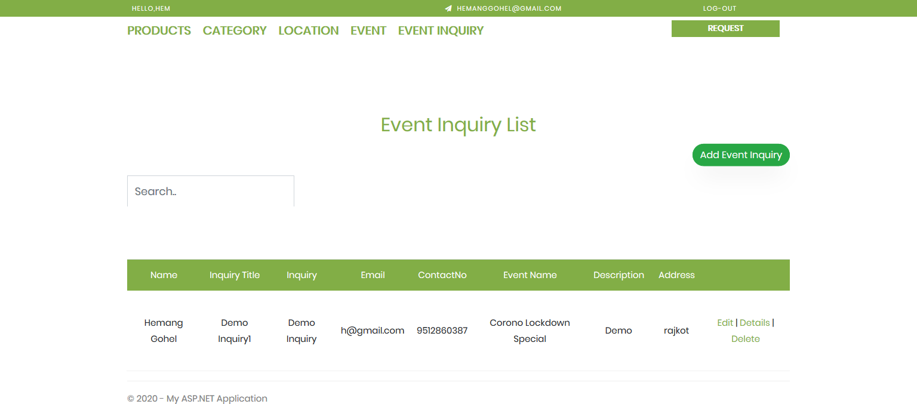

Figure 8.16 Event-Inquiry-List with Edit, Details and Delete Page

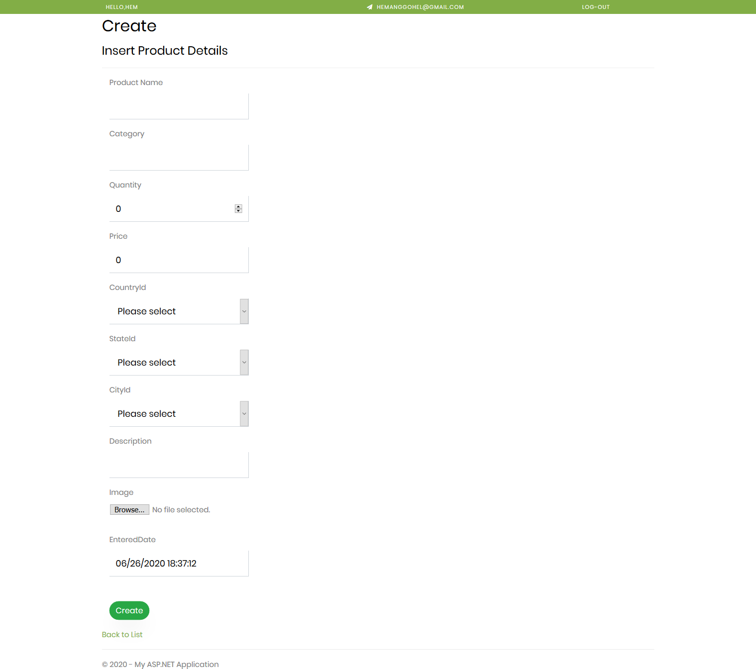

Figure 8.17 Add Product Page (Same for Categories, Locations and Events)

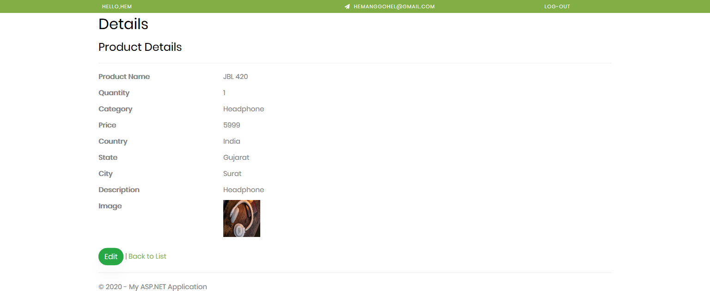

Figure 8.18 Product Details Page (Same for Categories, Locations and Events)

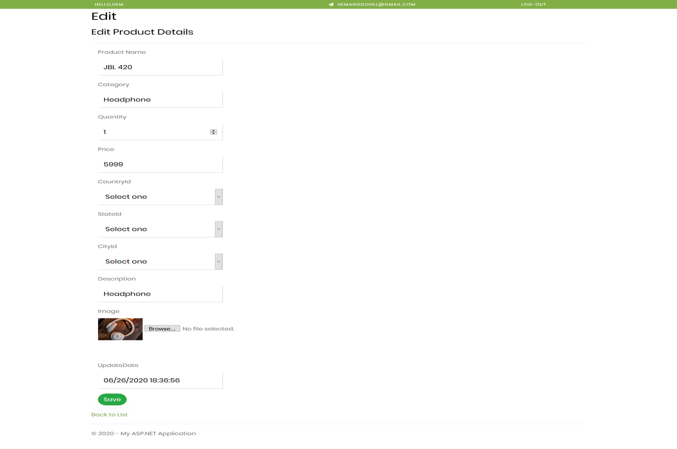

Figure 8.19 Edit Product Page (Same for Categories, Locations and Events)

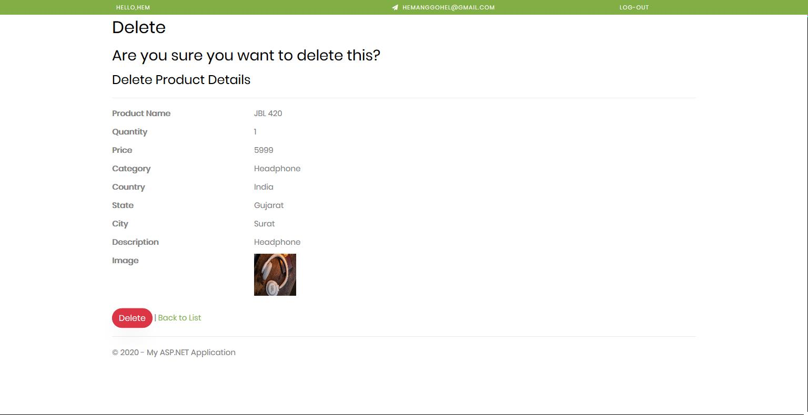

Figure 8.20 Delete Product Page (Same for Categories, Locations and Events)

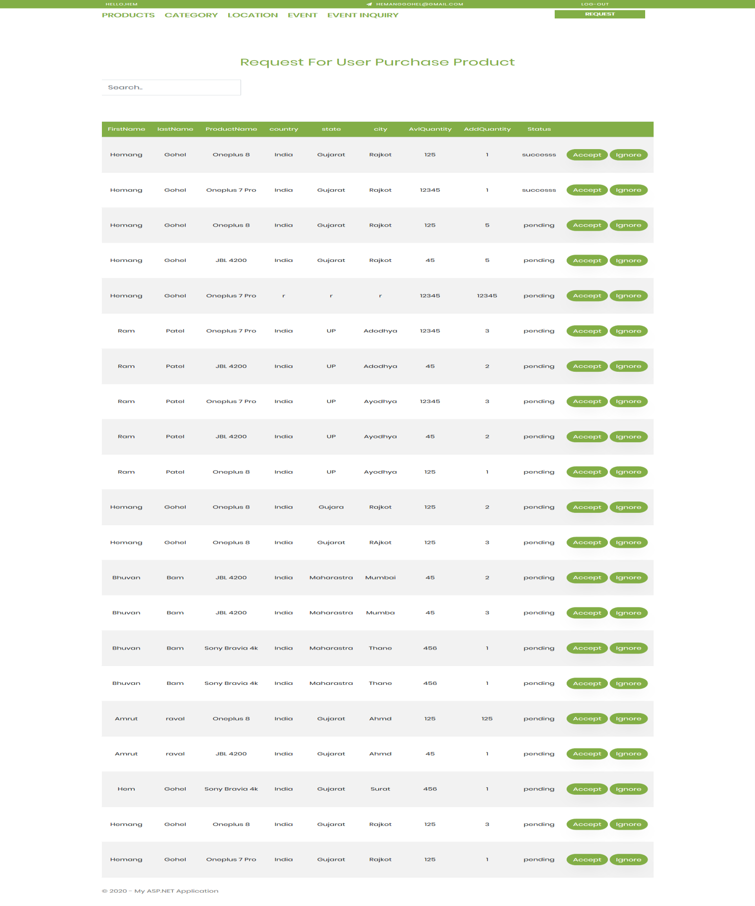

Figure 8.21 Product Purchasement Request Page for Admin

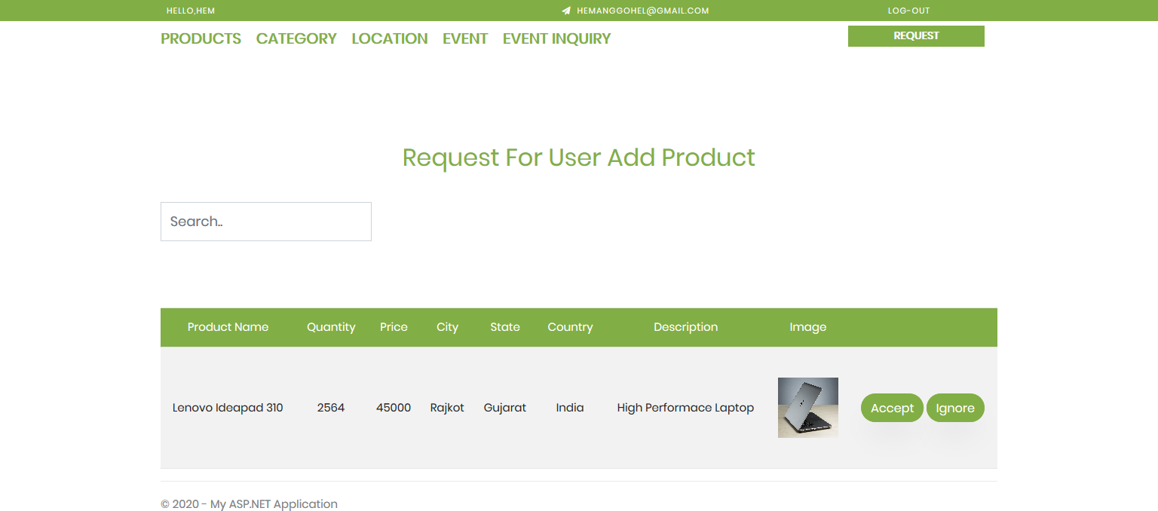

Figure 8.22 Add Product Request Page for Admin

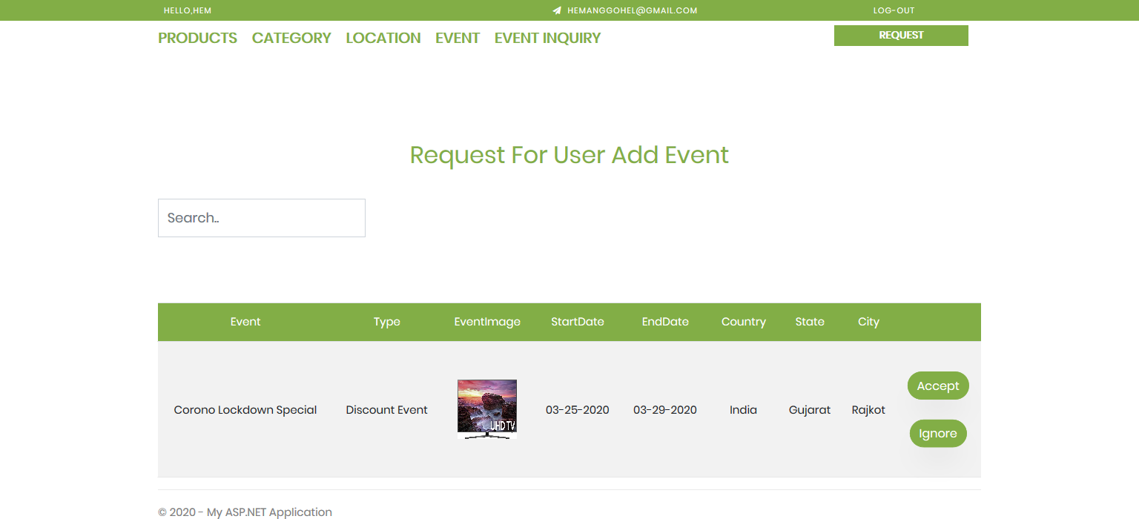

Figure 8.23 Add Event Request Page for Admin

# LIMITATIONS AND FUTURE ENHANCEMENT

## LIMITATIONS

* + - Proper internet connection is required to smoothly use web application.
    - Current systems do not support return and replacement of products.
    - Current systems do not provide functionality to cancel pre-requested orders.
    - Current systems do not support payment gateway for product purchasement.
    - Current systems do not provide functionality to share product details to others.

## FUTURE ENHANCEMENT

* + - Pre-Requested Orders Cancellation can be implemented.
    - Payment Gateway for Product Purchasement can also be added.
    - Share Product Details to Others can be provided.
    - User contact/complaint forum can be implemented.

# CONCLUSION AND DISCUSSION

## CONCLUSION

This web application that we have developed is very useful to purchase a product according to their requirement they can search the category and location and get the data related their requirement. it is a process of promoting and selling a product to a customer, also it is defined as being the intermediary function between product development and increasing brand awareness. Most of the software development follows agile scrum model. It requires continues development, testing and publish. This web application eases the process of testing and deployment of software/applications. Also, this application gives functionality of interact with portal as guest user, guest can interact with system same as registered user except product purchasement. Admin can see logs, manage portals data, user access information, system configurations and reports of same.

## DISCUSSION

### Self-Analysis of Project Viabilities

We have developed “Product Marketing and Selling Portal (PMSP)” with great concern and have tried our best to implement as many as features to make it viable and usable.

This system is a powerful and easy-to-use tool for every aged group people who are concern with their and wants to interact on daily basis.

It is the Application with the latest platform that fulfils the required users.

With some further modification it can compete with the available tools. According to feasibility analysis, it is feasible to all the users who are willing to communicate with other users.

### Problem Encountered and Possible Solutions

**Problem**: One of the major problems faced while making this app was to make web application single page web application.

**Solution**: we tried out many ways to solve it and worked for many days and at last got a solution that was to make ajax calls to controller on change of state of DOM elements.

**Problem**: another problem faced during the development of the project was to authenticate user based on token and authorize user based on his role.

**Solution**: after spending few days, we created custom authentication filter for token based authentication.

### Summary of Project Work

At the time of project, it is our pleasure to summarize all the project work done during the whole semester.

When our team got project, we have tried to understand the project concept and different areas related to this project. Then our team including our team leader have planned our whole project according to Planning Management.

Our Team Leader have scheduled whole Software Engineering activities that are related with our software and allocated days to complete particular activities and discussed with whole team.

Then we tried to strictly follow those scheduled activities and also calculated risks that are related to our project.

# REFERENCES

1. Wikipedia,” Visual Studio, SQL Server, C# & .NET framework” [https://en.wikipedia.org/wiki/](https://en.wikipedia.org/wiki/Raspberry_Pi)
2. Simplilearn,” Project Feasibility”

<https://www.simplilearn.com/feasibility-study-article>

1. Projectmanager, “Project Planning and Scheduling”

<https://www.projectmanager.com/project-planning>

1. Opentextbc, “Project implementation planning”

[https://opentextbc.ca/projectmanagement/chapter/chapter-17-project-implementation-](https://opentextbc.ca/projectmanagement/chapter/chapter-17-project-implementation-overview-project-management/) [overview-project-management/](https://opentextbc.ca/projectmanagement/chapter/chapter-17-project-implementation-overview-project-management/)

1. Geeksforgeeks, “Coding standards in project report”

<https://www.geeksforgeeks.org/coding-standards-and-guidelines/>

1. Softweretestinghelp, “Project Testing”

https://[www.softwaretestinghelp.com/test-project-planning/](http://www.softwaretestinghelp.com/test-project-planning/)

1. Wrike, “Agile Methodology”

[https://www.wrike.com/project-management-guide/faq/what-is-agile-methodology-in-](https://www.wrike.com/project-management-guide/faq/what-is-agile-methodology-in-project-management/) [project-management/](https://www.wrike.com/project-management-guide/faq/what-is-agile-methodology-in-project-management/)

1. Draw.io, “Project Diagrams”

<https://app.diagrams.net/>

# EXPERIENCE

* + The experience, learning and the environment provided to us during the entire internship was worth knowing.
  + Coding, as a skill that had been done during entire internship helped us learn that writing code that is more understandable and maintainable should be a rule of thumb and should be followed by each individual.
  + Also, got the actual experience how an IT firm works and manages its assets according to the requirements.